**Microsoft Excel Comprehensive  
From Beginner to Expert**

Welcome

Introduction

Understanding spreadsheets

Understanding versions

How to succeed

Course resources

Accelerate learning

Exercises - Ninja Level 1

Quiz - introduction

Hands-on exercise #1

Hands-on exercise #2

Hands-on exercise #3

Hands-on exercise #4

Writing formulas

Workbooks and worksheets

Finding your way around Excel

Mouse pointer awareness

Writing formulas

Relative, absolute, & mixed references

Ranges & names

Exercises - Ninja Level 2

Quiz - getting started

Hands-on exercise #1

Hands-on exercise #2

Hands-on exercise #3

Hands-on exercise #4

Hands-on exercise #5

Hands-on exercise #6

Hands-on exercise #7

Hands-on exercise #8

Hands-on exercise #9

Hands-on exercise #10

Formatting

Overview

Content & form

Format cells - number

Format cells - alignment

Format cells - font

Format cells - border

Format cells - fill

Clear formats

Format as table

Exercises - Ninja Level 3

Hands-on exercise #1

Hands-on exercise #2

Hands-on exercise #3

Hands-on exercise #4

Hands-on exercise #5

Hands-on exercise #6

Hands-on exercise #7

Home & insert

Overview

Copy as picture

Paste

Paste special

Format columns & rows

Styles

Pictures & shapes

Smart art, word art, & symbol

Link & text box

Add-ins

Exercises - Ninja Level 4

Hands-on exercise #1

Hands-on exercise #2

Hands-on exercise #3

Hands-on exercise #4

Hands-on exercise #5

Hands-on exercise #6

Hands-on exercise #7

Hands-on exercise #8

Hands-on exercise #9

Layout essentials

Overview

Background

Stacking order

Align, group, rotate

Zooming in & out

Templates

Exercises - Ninja Level 5

Hands-on exercise #1

Hands-on exercise #2

Hands-on exercise #3

Hands-on exercise #4

Hands-on exercise #5

Functions

Introduction

Average, max, min

Count & documentation

Round, roundup, rounddown

Rand & randbetween

Concatenate

Days & now

If

Exercises - Ninja Level 6

Hands-on exercise #1

Hands-on exercise #2

Hands-on exercise #3

Hands-on exercise #4

Hands-on exercise #5

Hands-on exercise #6

Hands-on exercise #7

Hands-on exercise #8

Hands-on exercise #9

Hands-on exercise #10

Congratulations

*** *** *** INTERMEDIATE EXCEL *** *** ***

Working with Data

Acquiring data

Importing text data

Sort

Vlookup

Freeze frames

Vlookup & sort

Filter

Advanced filter

Find & replace

Exercises - Ninja Level 7

Hands-on exercise #1

Hands-on exercise #2

Hands-on exercise #3

Hands-on exercise #4

Hands-on exercise #5

Hands-on exercise #6

Hands-on exercise #7

Hands-on exercise #8

Hands-on exercise #9

Hands-on exercise #10

Progressing with data

Overview

Text to columns

Flash fill

Remove duplicates

Data validation

Consolidate

What if - goal seek

What if - scenario

What if - data table

Forecasts

Exercises - Ninja Level 8

Hands-on exercise #1

Hands-on exercise #2

Hands-on exercise #3

Hands-on exercise #4

Hands-on exercise #5

Hands-on exercise #6

Hands-on exercise #7

Hands-on exercise #8

Hands-on exercise #9

Hands-on exercise #10

Displaying data

Overview

Group

Subtotal

Visually representing data

Chart creation

Chart creation II

Chart formatting

Chart formatting II

Chart sparklines

Combo chart

Chart trendlines

Exercises - Ninja Level 9

Hands-on exercise #1

Hands-on exercise #2

Hands-on exercise #3

Hands-on exercise #4

Hands-on exercise #5

Viewing & printing

Split window

Multiple windows

Helpful printing views

Page break adjustments

Including layout items

Exploring page setup

Adding a header & footer

Printing & printing to file

Exercises - Ninja Level 10

Hands-on exercise #1

Hands-on exercise #2

Hands-on exercise #3

Hands-on exercise #4

Hands-on exercise #5

Hands-on exercise #6

Hands-on exercise #7

Hands-on exercise #8

Functions - logical

Overview

na

ifna

if

iferror

true & false

not

and

or

xor

Exercises - Ninja Level 11

Hands-on exercise #1

Hands-on exercise #2

Hands-on exercise #3

Hands-on exercise #4

Hands-on exercise #5

Hands-on exercise #6

Functions - text

Overview

Capitalization

Joining text

Replacing text

Finding text

Text length

Text equality

Trimming text

Exercises - Ninja Level 12

Hands-on exercise #1

Hands-on exercise #2

Hands-on exercise #3

Hands-on exercise #4

Hands-on exercise #5

Hands-on exercise #6

Hands-on exercise #7

Functions - date & time

Dates & times

Current date time

Created date time

Extracting date time

Finding durations

Finding the future

Exercises - Ninja Level 13

Hands-on exercise #1

Hands-on exercise #2

Hands-on exercise #3

Hands-on exercise #4

Hands-on exercise #5

Hands-on exercise #6

Functions - lookup & reference

Overview

vlookup

hlookup

index

match

choose

transpose

row(s) column(s)

references

Exercises - Ninja Level 14

Hands-on exercise #1

Hands-on exercise #2

Hands-on exercise #3

Hands-on exercise #4

Functions - information

info

cell

iseven & isodd

na & isna

iserror & iserr

Checking contents 1

Checking contents 2

Top 10 functions

Exercises - Ninja Level 15

Hands-on exercise #1

Hands-on exercise #2

Hands-on exercise #3

Hands-on exercise #4

Full completion

Overview

Custom views

Conditional formatting

Objects & equations

Selection pane

Translating

Proofing

Insights

Exercises - Ninja Level 16

Hands-on exercise #1

Hands-on exercise #2

Hands-on exercise #3

Hands-on exercise #4

Hands-on exercise #5

Hands-on exercise #6

Office 365

Cloud based apps

MS Office vs Office 365

Functions and charting

vlookup

Exercises - Ninja Level 17

Hands-on exercise #1

Hands-on exercise #2

Google Drive

Introduction

Functions & charting

vlookup

forms

quizzes

Google trends

Exercises - Ninja Level 18

Hands-on exercise #1

Hands-on exercise #2

Hands-on exercise #3

Good to know

Protecting yourself online

Scrolling sheets

File extensions

Ethnocentricity

Where we’ve been

Congratulations

*** *** *** ADVANCED EXCEL *** *** ***

Financial functions I

Financial health

Time is money

Future value I

Future value II

Future value III

Future value IV

Present value

Present value II

Exercises - Ninja Level 19

Hands-on exercise #1

Hands-on exercise #2

Hands-on exercise #3

Hands-on exercise #4

Hands-on exercise #5

Hands-on exercise #6

Hands-on exercise #7

Financial functions II

Loan payment

Loan amortization

Annuity payment

Payment & interest

NPV

IRR

Exercises - Ninja Level 20

Hands-on exercise #1

Hands-on exercise #2

Hands-on exercise #3

Hands-on exercise #4

Hands-on exercise #5

Pivot tables

Introduction

Pivoting your data

Data into information

Adding information to a table

Refreshing pivot tables

Nesting with pivot tables

Grouping in pivot tables

Using slicers in pivot tables

Using timelines in pivot tables

Creating pivot charts

Recommended pivot tables

Exercises - Ninja Level 21

Hands-on exercise #1

Hands-on exercise #2

Hands-on exercise #3

Hands-on exercise #4

Hands-on exercise #5

Hands-on exercise #6

Hands-on exercise #7

Data model (power pivot)

Introduction

Add to data model

Creating relationships

Calculated columns

Writing a measure

Pivot your data

Exercises - Ninja Level 22

Hands-on exercise #1

Hands-on exercise #2

Get & transform (power query)

Orientation

1,048,576+ records

Excel broke

1,048,576+ records II

Get csv files

Adding data

Get txt files

Get xlsx files, single sheets

Get xlsx files, many sheets

Data preparation

Get txt, csv, accd, xlsx

Get web

Get JSON

Exercises - Ninja Level 23

Hands-on exercise #1

Hands-on exercise #2

Hands-on exercise #3

Hands-on exercise #4

Hands-on exercise #5

Transforming data

Overview

Split by delimiter

Pivot

Unpivot

Replace

Extract

Format

Exercises - Ninja Level 24

Hands-on exercise #1

Hands-on exercise #2

Hands-on exercise #3

Hands-on exercise #4

Hands-on exercise #5

Hands-on exercise #6

Hands-on exercise #7

Append & merge

Append

Append updating

Merge & joins

Left outer join

Right outer join

Full outer join

Inner join

Left anti join

Right anti join

Exercises - Ninja Level 25

Hands-on exercise #1

Hands-on exercise #2

Hands-on exercise #3

Hands-on exercise #4

Hands-on exercise #5

Hands-on exercise #6

Hands-on exercise #7

Hands-on exercise #8

Data visualization

Overview

3-D map

3-D map II

3-D map III

3-D map IV

3-D map animation

Themes

Defined names

Defined names & tables

Defined names management

Formula auditing

Error checking

Evaluate formula

Watch window

Calculation

Exercises - Ninja Level 26

Hands-on exercise #1

Hands-on exercise #2

Hands-on exercise #3

Hands-on exercise #4

Hands-on exercise #5

Hands-on exercise #6

Collaborating

Signature line

Comments

Accessibility

Protect (lock)

Exercises - Ninja Level 27

Hands-on exercise #1

Automation

Understanding macros

Relative reference macros

Exercises - Ninja Level 28

Hands-on exercise #1

Excel & Word integration (OLE)

Object linking & embedding (OLE)

Exercises - Ninja Level 29

Hands-on exercise #1

Farewell

Great work!

# Welcome

1. **welcome**

Welcome to Microsoft Excel Comprehensive

1. **credentials**

My name is Todd McLeod and …

* 20 years experience teaching MS Office & Excel
  + college and university level
* Microsoft Certified Master Instructor

1. **audience**

For those new to spreadsheets … For those already with experience ...

1. **benefits**

* great **skills** with Excel
* great **learning** 
  + education hierarchy
    - skills / knowledge / wisdom / motivation / inspiration
* great **efficiency**
  + content first; anecdotes second
* great **thoroughness**
  + zero → hero
* great **community**
* great **fun**
* great **production quality**
* great **course**
  + [**former students say: https://goo.gl/MLy38w**](https://goo.gl/MLy38w)

1. **curriculum**

The curriculum we will be studying …

* [**course outline: https://goo.gl/RS7XtF**](https://goo.gl/RS7XtF)
* [**course files: https://goo.gl/rA7FAM**](https://goo.gl/rA7FAM)
  + including quizzes
* [**Version: MS Excel 2016**](https://en.wikipedia.org/wiki/Microsoft_Office#Version_history#Timeline_of_releases)

1. **join us**

* This is absolutely the best training for MS Excel in the world.
* So enroll now. Join us on this amazing journey. Let’s get started and have some fun!

**video: 001**

# Introduction

## Understanding spreadsheets

* Spreadsheets allow us to work with numbers. Spreadsheets are like **customizable calculators**. Spreadsheets also allow us to **organize and manage data**.

**file: 01-beginner/001\***

**video: 01-001**

## Understanding versions

* Microsoft Excel comes in many different versions. Every few years, Microsoft releases a new version of Excel. Understanding the different versions available, and which version you are using, is helpful. **In this course, we will be using the most current version of Microsoft Excel at the time of the recording: Microsoft Excel 2016**.

**file:** [**Versions of MS Excel**](https://en.wikipedia.org/wiki/Microsoft_Office#Version_history#Timeline_of_releases)

**video: 01-002**

## How to succeed

Understanding what has made others successful can help you become successful. These are principles which have helped me become successful. I learned these principles from others and from my own experience. I share these **principles to help you succeed in this course and in life:**

* Time on task
* Grit
  + [Angela Duckworth: Grit: the power of passion and perseverance](https://www.youtube.com/watch?v=H14bBuluwB8)
* Focus
  + Bill Gates & Warren Buffett
  + Bill Gates, “Get in front of what’s coming and let it hit you.”
* [Habits of effective people](https://drive.google.com/drive/folders/0B22KXlqHz6ZNYm4wZWxwLTB5RVE?usp=sharing)
* my teachers
  + drop by drop, the bucket gets filled
  + persistently, patiently, you are bound to succeed

**video: 01-003**

## Course resources

The course outline is part of the course. Please **read all of the descriptions of the videos in the course outline.** This is part of the learning process. When you read the descriptions:

* the concepts you are learning will be reinforced
* you will **learn the material more quickly**

In addition, I sometimes provide additional information in the course descriptions. Sometimes I record a lecture, then remember that there is a resource or another piece of information which you should know. Some of these resources and extra pieces of information I include are very valuable.

* course outline
  + comprehensive
    - <https://goo.gl/RS7XtF> **AND** [**ALL EXERCISE FILES ARE HERE**](https://goo.gl/zhfwwA)
  + beginner
    - <https://goo.gl/v4v7yC> **AND** [**ALL EXERCISE FILES ARE HERE**](https://goo.gl/zhfwwA)
  + intermediate
    - <https://goo.gl/us9byy> **AND** [**ALL EXERCISE FILES ARE HERE**](https://goo.gl/zhfwwA)
  + advanced
    - <https://goo.gl/x37Wm4> **AND** [**ALL EXERCISE FILES ARE HERE**](https://goo.gl/zhfwwA)
* course files
  + [**Google Drive**](https://goo.gl/rA7FAM) **AND** [**ALL EXERCISE FILES ARE HERE**](https://goo.gl/zhfwwA)
  + [**GitHub**](https://github.com/GoesToEleven/microsoft-excel)
    - downloading zip
* **Todd McLeod YouTube**
  + [**https://www.youtube.com/user/toddmcleod**](https://www.youtube.com/user/toddmcleod)
* **Todd McLeod Twitter** 
  + [**https://twitter.com/Todd_McLeod**](https://twitter.com/Todd_McLeod)

**video: 01-004**

## Accelerate learning

You can **increase the speed of videos when you watch them**. Not everyone knows this. This is something you should include in the beginning of all of your courses. Watching videos quickly helps many students. It’s not for everybody, but it works for a lot of people. You need your students to know about this. You can also turn on the **“tools / document outline” for our course outline**.

**video: 01-005**

# Exercises - Ninja Level 1

## Quiz - introduction

Quizzes help you learn the material more quickly. By taking [this quiz](https://goo.gl/forms/CapODOZK6jB4sbMD3), you are engaging your mind. By working to recall the material, the material is more deeply integrated. **Take this quiz to more quickly learn!** [Take the quiz now.](https://goo.gl/forms/CapODOZK6jB4sbMD3)

**video: 01-006**

## Hands-on exercise #1

* What **version of Microsoft Excel** are you using? Is this the most current version?

**video: 01-007**

## Hands-on exercise #2

* Is your computer a **32-bit or 64-bit** machine?

**video: 01-008**

## Hands-on exercise #3

* **Tell a friend or family member about spreadsheets and Microsoft Excel.** Explain to them your understanding of both “spreadsheets” and “Microsoft Excel.”

**video: 01-009**

## Hands-on exercise #4

* Grab a piece of paper and a pen. **Write out the principles for student success.** Write a commitment to yourself as to **how frequently, and how much, you will dedicate yourself** to learning Excel. For instance, you might write, “I will study Excel every day for at least 30 minutes until I have finished the course.” **Post this paper where you, and everyone else in your household, can see it every day.**

**My solution:**



**video: 01-010**

# Writing formulas

## Workbooks and worksheets

A workbook has worksheets. **When you open a Microsoft Excel file you are opening a workbook. Inside that workbook you will find worksheets.** You can add and delete worksheets as needed.

* terminology
  + **workbook**
  + **worksheet**
* skills
  + **Starting Excel**
  + **Saving a file**
  + **Closing Excel**
  + **Opening a file**

**file: 011-my-first-workbook**

**video: 01-011**

## Finding your way around Excel

* Spreadsheets are made up of **columns and rows**.
* The intersection of a column and row is a **cell**.
  + The **active cell** has a green or black box around it.
  + Each cell has a **cell address**: column row, eg, B2.
* Every Excel file is known as a **workbook**.
  + Each workbook has **worksheets**.
* to **enter data into a cell**, click on the cell and start typing
  + you can **edit data in a cell** by
    - double-clicking the cell
    - or up in the **formula bar**
  + cells overflow if there is no data in the adjacent cell
* you can **make columns wider**
* **ribbon menus**
  + give you different choices
  + **file menu**
    - hit the arrow to go back
  + you can **collapse your ribbon**, and **pin back in place**
  + **view ribbon**
    - change view
    - print view
    - **gridlines**
  + **page layout**
    - **gridlines**
    - **headings**
* **status bar**
  + **count**
  + **average**
  + **sum**
* **Learning tip: jump to hands-on Exercises to reinforce this material**

**file: 012-Finding-Your-Way-Around-Excel**

**video: 01-012**

## Mouse pointer awareness

While using Excel, your mouse pointer will change depending upon the context. **Paying attention to the way your mouse pointer looks, and knowing what the different looking mouse pointers mean, will help you use Excel more effectively.** Also covered in this video:

* **worksheets**
  + **name, color, position**
    - You can name the tabs of these worksheets, change their colors, and change their order. Right-clicking is helpful for this.
  + **add**
    - You can add new worksheets to your workbook by clicking the plus sign.

**file: 013-Mouse-Pointer-Awareness**

**video: 01-013**

## Writing formulas

Learn the basics of writing formulas in Excel including the point-and-click method for writing formulas.

* writing formulas
  + **=**
  + ‘=
* **point-and-click method**
* order of operations
* **relative references**
* formula ribbon
  + **show formulas**

**file: 014-Writing-Formulas**

**video: 01-014**

## Relative, absolute, & mixed references

Learn how to use relative, absolute, and mixed references when writing formulas in Excel.

* **relative**
* **ab$olute**
* **mixed**

**file: 015-references-rel-absolute**

**video: 01-015**

## Ranges & names

* **range**
  + a selection of 2+ cells
* **colon notation**
  + B9:F9
* **names**
  + named cells & ranges

**file: 016-ranges-colon-notation**

**video: 01-016**

# Exercises - Ninja Level 2

## Quiz - getting started

Quizzes help you **learn the material more quickly.** By taking [this quiz](https://goo.gl/forms/ps6nkmtOjAe3OdLP2), you are engaging your mind. By working to recall the material, the material is more deeply integrated. [Take this quiz](https://goo.gl/forms/ps6nkmtOjAe3OdLP2) to more quickly learn!

**video: 01-017**

## Hands-on exercise #1

Create a new excel spreadsheet. Do the following:

* create a new worksheet
  + name it “Happy items”
  + give the worksheet tab a color
  + move the worksheet tab to the front of the tabs
* starting in cell B2
  + **list five items that make you happy**
    - one item in each cell: B2, B3, B4, B5, B6
* Delete the other worksheets
  + right-click the worksheets
* edit the entry in cell B3
  + use the double-click method
* edit the entry in cell B4
  + use the formula bar

**video: 01-018**

## Hands-on exercise #2

Create a new workbook. Do the following:

* make sure you are using **normal view**
* remove the **gridlines**
* collapse the ribbon menu
  + pin the **ribbon menu** back into place

**video: 01-019**

## Hands-on exercise #3

Open the “020-hands-on-03” workbook. Using the “sales data” worksheet:

* For items F4:F21, what is the
  + **count**
  + **average**
  + **sum**

**file: 020-hands-on-03**

**video: 01-020**

## Hands-on exercise #4

Open the “021-hands-on-04” workbook. Write a formula which adds up B4:B7. Use **relative references** in your formula. Use the autofill handle to copy that formula across B8:M8

**file: 021-hands-on-04**

**video: 01-021**

## Hands-on exercise #5

Open the “021-hands-on-05” workbook. Write a formula which calculates the tax. Use an **absolute reference**. Use autofill to copy the formula.

**file: 022-hands-on-05**

**video: 01-022**

## Hands-on exercise #6

* **Calculate the grade for each student.** Assume each graded item carries equal weight. To calculate the grade for each student, just calculate the average score of all scores for that student.
* **Calculate the class average for each graded item.**

**file: 023-hands-on-06**

**video: 01-023**

## Hands-on exercise #7

* **Calculate the grade for each student.** Each graded item does not carry equal weight. To calculate the grade for each student, you will need to do a weight average calculation.
* **Calculate the class average for each graded item.**

**file: 024-hands-on-07**

**video: 01-024**

## Hands-on exercise #8

* **Calculate the grade for each student.** This gradebook is using the points method. To calculate the grade for each student, just add up a student’s points then divide that by total points possible.
* **Calculate the class average for each graded item.**

**file: 025-hands-on-08**

**video: 01-025**

## Hands-on exercise #9

Calculate **the costs for a trip to Disneyland** in Anaheim, California, for yourself and three others. Have your trip last 5 days at the Disneyland & California Adventure parks.

* ticket price for both Disneyland & Cal Adventure
* airfare
* hotel
* $500 per person for food & incidentals

**file: 026-hands-on-09**

**video: 01-026**

## Hands-on exercise #10

Create a spreadsheet that has the recipe for[**oatmeal peanut butter chocolate chip cookies**](http://www.epicurious.com/recipes/food/views/joses-oatmeal-peanut-butter-chocolate-chip-cookies-11797)**.**

* include the quantities
* include the ability for the **quantities to multiply by the number of batches** desired.

**file: 027-hands-on-10**

**video: 01-027**

# Formatting

## Overview

Formatting your worksheets is important. Join me on **a quick tour of some of things we will learn** about formatting worksheets.

**file: 028-formatting-Introduction**

**video: 01-028**

## Content & form

It is **not only what you say that matters (the content) but also how you say it (the form).** When studied, the greatest impact upon others isn’t the content, but the form. The 7 38 55 study from UCLA says that what impacts people in public speaking is:

* 7% the content
* 38% how it’s said
* 55% body language

This is true in public speaking, this is true in art, this is true in job interviews, and this is true in your Excel spreadsheets. Take your content and give it good form (make it look good).

**video: 029-content-form**

## Format cells - number

We can format the cells of a worksheet to **display different types of data**:

* General
* Number
* Currency
* Accounting
* Date
* Time
* Percentage
* Fraction
* Scientific
* Text
* Special
* Custom

**file: 030-format-cells-number**

**video: 030-format-cells-number**

## Format cells - alignment

The alignment tab in the format cells dialog box allows you to **align your text**:

* horizontal
* vertical
* orientation (angle)
* wrap
* merge
* shrink-to-fit

Using the alignment tab, we can quickly achieve some very nice visual looks.

**file: 031-format-cells-alignment-copy-of-025-hands-on-08-solution**

**video: 031-format-cells-alignment**

## Format cells - font

In graphic design, **font determines feeling**. There are two broad categories of fonts: serif and sans-serif. A serif font has feet; a sans-serif font does not. For text on computer screens, sans-serif is the most popular and, perhaps by consensus, best choice. You can find the most popular fonts in the world on [Google Fonts](https://fonts.google.com/). Once the fonts are installed on your computer, you can use them in your spreadsheets. Take-aways:

* **use a sans-serif font**
* **use Google Fonts to get the most popular fonts**

**file: 032-format-cells-font**

**video: 032-format-cells-font**

## Format cells - border

The “format cells” dialog box “border” option allows us to **set borders around a cell or range of cells.**

**file: 033-format-cells-border**

**video: 033-format-cells-border**

## Format cells - fill

The “format cells” dialog box “fill” option allows us to **fill a cell, or range, with a color and pattern.**

**file: 034-format-cells-fill**

**video: 034-format-cells-fill**

## Clear formats

The “clear” option on the “home” ribbon allows you to **clear different elements** on your spreadsheet:

* clear all
* clear formats
* clear contents
* clear comments
* clear hyperlinks

**file: 035-clear-formats**

**video: 035-clear-formats**

## Format as table

You can **quickly format tabular data as a table** using the “format as table” option on the home ribbon. Two good things to know about:

* filter checkbox
* convert to range

**file: 036-format-as-table**

**video: 036-format-as-table**

# Exercises - Ninja Level 3

## Hands-on exercise #1

Using the format cells dialog box, **format various data as different numbers**.

**file: 037-hands-on-01**

**video: 037-hands-on-01**

## Hands-on exercise #2

Use the "format cells" dialog box "alignment" tab to **align cell contents**.

**file: 038-hands-on-02-format-cells-alignment-copy-of-025-hands-on-08-solution**

**video: 038-hands-on-02**

## Hands-on exercise #3

Using the "format cells" dialog box "font" tab:

* **Use "Roboto regular" from Google Fonts for all text.**
* **Also make sure to "superscript" the 42 in cell V27.**

**file: 039-hands-on-03-format-cells-font**

**video: 039-hands-on-03**

## Hands-on exercise #4

Using the "format cells" dialog box, **work with the "fill" & "border" tabs** for format your spreadsheet.

**file: 040-hands-on-04-format-cells-border-and-fill**

**video: 040-hands-on-04**

## Hands-on exercise #5

Use the “clear” button on the home ribbon to **clear the formatting on a spreadsheet.**

**file: 041-hands-on-05-clear-formats**

**video: 041-hands-on-05**

## Hands-on exercise #6

Use the “format as table” button on the home ribbon to **format data as a table.**

**file: 042-hands-on-06**

**video: 042-hands-on-06**

## Hands-on exercise #7

**Format this spreadsheet** and make it look pretty.

**file: 043-hands-on-07-format-this**

**video: 043-hands-on-07**

# Home & insert

## Overview

An overview of **what we have learned so far,** and **what we will learn next.**

**files: 044 png files**

**video: 044-overview**

## Copy as picture

In hands-on #7 in Ninja Level 3 you saw me use the “snipping tool” to capture a picture of something in Excel. You can also **capture a picture in Excel with “copy as picture.”** This workflow, however, is not quite as elegant as using the snipping tool.

**file: 045-copy-as-picture**

**video: 045-copy-as-picture**

## Paste

Paste has a few options which are useful to know about. These paste options allow us to **determine how items we have copied are pasted:**

* paste
* paste formula
* paste value
* paste transpose

**file: 046-paste**

**video: 046-paste**

## Paste special

We can copy data from the web and then **use “paste special” to determine how that data is pasted into Excel.**

* <https://finance.yahoo.com/quote/TSLA/history?p=TSLA>

**file: 047-paste-special**

**video: 047-paste-special**

## Format columns & rows

We can use the “format” option on the home ribbon to **format options for column and rows:**

* width
* height
* hide & unhide

**file: 048-format-columns-rows**

**video: 048-format-columns-rows**

## Styles

You can **quickly apply formatting using styles from the home ribbon.**

**file: 049-styles**

**video: 049-styles**

## Pictures & shapes

Excel makes it easy to **insert pictures and shapes (arrows, smiles, stars) into worksheets.**

* pictures
* online pictures
* shapes
* screenshot

**file: 050-pictures-shapes**

**video: 050-pictures-shapes**

## Smart art, word art, & symbol

* Smart art
  + **list**
  + **process**
  + **cycle**
  + **hierarchy**
  + **relationship**
  + **matrix**
  + **pyramid**
  + **picture**
* word art
* symbol
  + copyright
  + trademark
  + [**unicode characters**](https://en.wikipedia.org/wiki/List_of_Unicode_characters)

**file: 051-art-symbol**

**video: 051-art-symbol**

## Link & text box

You can **insert links** in your Excel worksheet. You can also **insert text boxes.**

**file: 052-link-text-box**

**video: 052-link-text-box**

## Add-ins

**Increase the functionality of Excel with third-party “add-ins”** such as maps.

**file: 053-add-ins**

**video: 053-add-ins**

# Exercises - Ninja Level 4

## Hands-on exercise #1

Using spreadsheet “054-hands-on-01-disney-trip” **use “copy as picture” to copy the table to a picture.** Paste that picture back into the spreadsheet.

**file: 054-hands-on-01-disney-trip**

**video: 054-hands-on-01**

## Hands-on exercise #2

Take the data in “055-hands-on-02” and **transpose** it from a column to a row. Important: only select the data, do not select the entire column. If you select the entire column, you will not be able to paste transpose.

**file: 055-hands-on-02**

**video: 055-hands-on-02**

## Hands-on exercise #3

Copy data from Yahoo finance, or data from somewhere else online, and **paste the data into Excel using paste special.**

* <https://finance.yahoo.com/quote/TSLA/history?p=TSLA>

**file: 056-hands-on-03**

**video: 056-hands-on-03**

## Hands-on exercise #4

Using “057-hands-on-04” **adjust the row and column height** to look good. **Hide columns** B & C.

**file: 057-hands-on-04**

**video: 057-hands-on-04**

## Hands-on exercise #5

Create a new spreadsheet. Save the spreadsheet as “058-hands-on-05.” Create a tab for each of the following, and then complete the tasks for each tab:

* **pictures**
  + *use Google to find an image that is labeled for reuse*
  + *save that image to your computer*
  + *insert that image into your spreadsheet*
* **online pictures**
  + *find an image using “online pictures” and insert it into your spreadsheet*
* **shapes**
  + *insert a star onto your spreadsheet*
* **screenshot**
  + *open a web page*
  + *go to excel, then insert a screenshot and choose “screen clipping”*
  + *the web page should come to the foreground and allow you to select a region of the web page*
  + *the selection of the web page should appear in excel*

**file: 058-hands-on-05**

**video: 058-hands-on-05**

## Hands-on exercise #6

Create a new spreadsheet. Save the spreadsheet as “059-hands-on-06.” Create a tab for each of the following, and then complete the tasks for each tab:

* **smart art**
  + insert a smart art of your choice
    - if applicable, add 5 options to it
* **word art**
  + insert this word art: “I’m learning so much about Excel!”
* **symbol**
  + insert the copyright © symbol

**file: 59-hands-on-06**

**video: 59-hands-on-06**

## Hands-on exercise #7

Create a new spreadsheet. Save the spreadsheet as “060-hands-on-07.” Create a tab for each of the following, and then complete the tasks for each tab:

* **link**
  + create a link to this poem
  + <https://www.thesunmagazine.org/issues/418/in-my-good-death>
* **text box**
  + insert a text box with this phrase
  + “My Excel skills are going up and up and up!”

**file: 060-hands-on-07**

**video: 060-hands-on-07**

## Hands-on exercise #8

Create a new spreadsheet. Save the spreadsheet as “061-hands-on-08.” Use an “add-in” on your spreadsheet.

**file: 061-hands-on-08**

**video: 061-hands-on-08**

## Hands-on exercise #9

Create a new spreadsheet. Save the spreadsheet as “062-hands-on-09.” Copy the Oscar winners from either of these urls …

* <https://en.wikipedia.org/wiki/List_of_Academy_Award-winning_films>
* <https://www.flickfilosopher.com/oscar-best-picture-winners-alphabetical>

… then use “paste special” to get it into Excel.

**file: 062-hands-on-09**

**video: 062-01-hands-on-09**

# Layout essentials

## Overview

This is an overview of **where we’ve been and where we’re going.** Looking at what we’ve covered, and what we’re going to cover, helps you learn. This is also referred to as “preview, view, review” and is a well-documented technique to help students learn more effectively.

**file: 062-02-overview**

**video: 062-02-overview**

## Background

You can **add a background image to your spreadsheet.** Use the “background” option from the page layout ribbon.

**file: 063-background**

**video: 063-background**

## Stacking order

The stacking order is **the order in which overlapping graphics stack.** This is also referred to as the vertical stacking order. You can change the vertical stacking order of graphics by using the “bring forward” and “send backward” buttons on the page layout ribbon.

* forward
* backward

**file: 064-stacking**

**video: 064-stacking**

## Align, group, rotate

You can use buttons on the page layout ribbon to **align, group, and rotate graphics.**

**file: 065-align-group-rotate**

**video: 065-align-group-rotate**

## Zooming in & out

Use options on the view ribbon to **zoom-in and zoom-out on your spreadsheet.**

* also: formula bar checkbox

**file: 066-zoom**

**video: 066-zoom**

## Templates

Templates are **pre-built worksheets.** Excel has a variety of templates which you can search for and use.

**file: 067-templates**

**video: 067-templates**

# Exercises - Ninja Level 5

## Hands-on exercise #1

Open the spreadsheet “068-hands-on-01.” Add a Disney related **background image** to this spreadsheet.

**file: 068-hands-on-01**

**video: 068-hands-on-01**

## Hands-on exercise #2

Open the spreadsheet “069-hands-on-02.” Change the **stacking order** of the images by putting the image of the beach in the background.

* forward
* backward

**file: 069-hands-on-02**

**video: 069-hands-on-02**

## Hands-on exercise #3

Open the spreadsheet “070-hands-on-03.” **Align** the graphics. Evenly **distribute** the graphics. **Group** the graphics. **Rotate** the graphics.

**file: 070-hands-on-03**

**video: 070-hands-on-03**

## Hands-on exercise #4

Find the **template** “weekly expense report”. Enter the following data:



Save the spreadsheet as “072-hands-on-05”

***note: in the video, the file names were incorrectly typed; these are the correct file names:***

**file: 071-hands-on-04**

**video: 071-hands-on-04**

## Hands-on exercise #5

Open “072-hands-on-05”, select the table of Disneyland trip data, then **zoom** in on it. Save the file. Re-open the file. Was the zoom level maintained?

**file: 072-hands-on-05**

**video: 072-hands-on-05**

# Functions

## Introduction

Functions are formulas that are already written for us.Functions allow us to **quickly calculate computations.** The **sum** function is covered in this video.

**file: 073-func-sum**

**video: 073-func-sum**

## Average, max, min

These functions allow you to calculate the **average** of a series of numbers, find the **max** value in a series of numbers, and find the **min** value in a series of numbers.

**file: 074-func-average-max-min**

**video: 074-func-average-max-min**

## Count & documentation

The count function allows you to count how many items are in a series.

* **count**
* **counta**
* **countif**

**file: 075-func-count**

**video: 075-func-count**

## Round, roundup, rounddown

The rounding functions allow you to round numbers. These functions are covered:

* **round**
* **roundup**
* **rounddown**

Documentation is also covered in this video. Also included is how to **copy examples out of documentation and get them into Excel.**

**file: 076-func-roundup**

**video: 076-func-roundup**

## Rand & randbetween

You can generate random numbers using **rand** and **randbetween**.

**file: 077-func-rand**

**video: 077-func-rand**

## Concatenate

The **concatenate** function allows you to join text together.

**file: 078-func-concatenate**

**video: 078-func-concatenate**

## Days & now

The days function allows you to count the number of days between two dates.

* **days**
* **now**

**file: 079-func-days**

**video: 079-func-days**

## If

The **if** function allows you to make a decision based upon the value in a cell.

**file: 080-func-if**

**video: 080-func-if**

# Exercises - Ninja Level 6

## Hands-on exercise #1

**Sum** up the numbers in the “ 081-hands-on-01” spreadsheet.

**file: 081-hands-on-01**

**video: 081-hands-on-01**

## Hands-on exercise #2

Open the spreadsheet for this exercise and use the following functions on the columns of numbers:

* **average**
* **max**
* **min**

**file: 082-hands-on-02**

**video: 082-hands-on-02**

## Hands-on exercise #3

Open the spreadsheet for this exercise and use the following function on the columns of data:

* **counta**

**file: 083-hands-on-03**

**video: 083-hands-on-03**

## Hands-on exercise #4

Open the spreadsheet for this exercise and use the following function on the column of numbers:

* **round**

Round to the precisions noted in the spreadsheet.

**file: 084-hands-on-04**

**video: 084-hands-on-04**

## Hands-on exercise #5

Use the **randbetween** function to automatically generate scores for the gradebook. Also, insert the appropriate functions in the areas highlighted in yellow.

* **randbetween**

**file: 085-hands-on-05**

**video: 085-hands-on-05**

## Hands-on exercise #6

Open the spreadsheet for this exercise and use the following function to concatenate the words in the spreadsheet together (with spaces between them):

* **concatenate**

**file: 086-hands-on-06**

**video: 086-hands-on-06**

## Hands-on exercise #7

Create a spreadsheet that calculates the number of days since man walked on the moon. And then also use the if function to determine if this number is greater than 8357. Save the spreadsheet as 087-hands-on-07.

* **now**
* **days**
* **if**

**file: 087-hands-on-07**

**video: 087-hands-on-07**

## Hands-on exercise #8

Copy **documentation** **examples** for the **round** func into Excel. Save the workbook as 088-hands-on-08.

**file: 088-hands-on-08**

**video: 088-hands-on-08**

## Hands-on exercise #9

**Create a gradebook** off of this syllabus which uses the points method.

**files:**

* **089-hands-on-09**
* **089-hands-on-09-syllabus**

**video: 089-hands-on-09**

## Hands-on exercise #10

**Create a gradebook** off of this syllabus which uses the weighted average method.

**files:**

* **090-hands-on-10**
* **090-hands-on-10-syllabus**

**video: 090-hands-on-10**

# Congratulations

You have done great work - the greatest work. You have taken steps to create a better life for yourself, and for others. As an individual improves their own life, they improve the world. The skills you are acquiring are some of the most valuable skills demanded today: knowing how to use Excel. Congratulations. You have done great.

**Next Steps:**

* [Follow me on Twitter](https://twitter.com/Todd_McLeod)
  + <https://twitter.com/Todd_McLeod/status/908342249347354625>
* Intermediate Excel
* Advanced Excel
* Comprehensive Excel
* Create your own course

**video: 091-congratulations**

# *** *** *** INTERMEDIATE EXCEL *** *** ***

# Working with Data

## Acquiring data

Excel is made for working with numbers; for taking data and turning it into information. In this section, we are going to dive into the **data ribbon**:



To work with data, we will need to get some data. A few sources we can use to **acquire data** with which to work:

* [Google finance - financials](https://finance.google.com/finance)
* [Yahoo finance - market history](https://finance.yahoo.com/lookup/)
* [US Census quickfacts](https://www.census.gov/quickfacts)
* [Google keyword planner](https://adwords.google.com/ko/KeywordPlanner)
* [Oscar winners](http://oscar.go.com/news/winners/oscar-winners-2017-see-the-complete-list)

**Hands on exercise:**

* copy data from each of the above sources and get it into Excel

**files:**

* **092-acquire-data**
* **092-lecture-prep-file**
* **092 many image files showing wha**

**video: 092-acquire-data**

## Importing text data

Data stored in a text file is often separated by a **delimiter**. Usually those delimiters are either a comma or a tab. You can also choose other delimiters if needed.

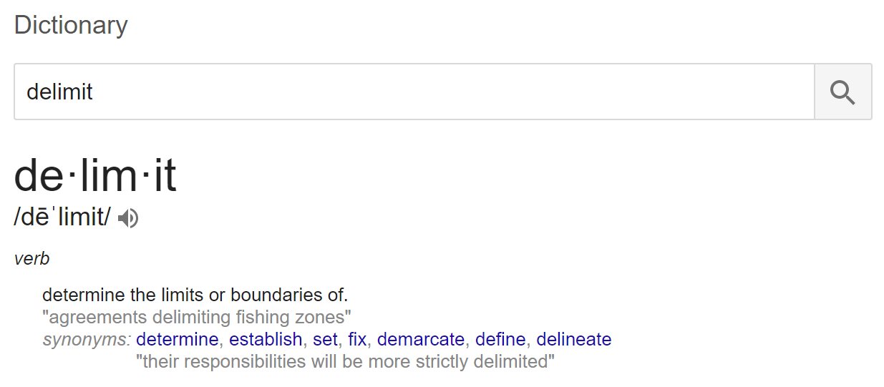

You can use the text import wizard dialogue box to **import text data into Excel.** It is an essential Excel skill to know how to use the text import wizard.

**Hands on exercises:**

* use the text import data wizard to import data from the following files:
  + 092-acquire-data-GOOG.csv
  + 092-acquire-data-Keyword Planner 2017-09-16 at 16-06-14.csv

**file: 093-import-text-data**

**video: 093-import-text-data**

## Sort

Sort allows us to **quickly sort data**. This is a powerful tool.

**Hands on exercises:**

* sort data
  + open up the file “093-import-text-data” in Excel. Sort the keyword data in this order:
    - Suggested bid smallest to largest
    - Competition smallest to largest

**file: 094-sort**

**video: 094-sort**

## Vlookup

Vlookup is another great and powerful tool. It allows us to **look a value up in a table of values, then return an associated value.** For instance, in a gradebook a student might have a score of 84%. I could use vlookup to then insert “B” next to the student’s grade.

**Hands on exercise:**

* lookup a percentage score then display a letter grade

**file: 095-vlookup**

**video: 095-vlookup**

## Freeze frames

Freeze frames allows us to freeze certain columns or rows in your worksheet. This is helpful so that you can **see headers associated with data as you scroll through the data.**

**Hands on exercise:**

* In the workbook “096-freeze-frames” use freeze frames in a way which makes sense for the worksheets.

**file: 096-freeze-frames**

**video: 096-freeze-frames**

## Vlookup & sort

We can use **vlookup and sort** to gain additional information from our Google Adwords Keyword data.

**Hands on exercise:**

* Replicate what was done in this video.

**file: 097-vlookup-sort**

**video: 097-vlookup-sort**

## Filter

We have seen how to sort data. Sort is a very useful tool. It allows us to put our data into a sorted order by criteria we specify. Another useful tool is filter. Filter allows us to filter our data by criteria we specify. When we filter data, we tell Excel to only **show certain data based upon certain criteria.**

**Hands on exercise:**

* Download Google Adwords Keywords relevant to your business or the business of a friend. In the same fashion demonstrated in this video, use filter and sort to build a list of keywords you might want to purchase.

**file: 098-filter**

**video: 098-filter**

## Advanced filter

Advanced filter should be called an “anachronism from the past.” **Advanced filter is clunky and awkward to use.**

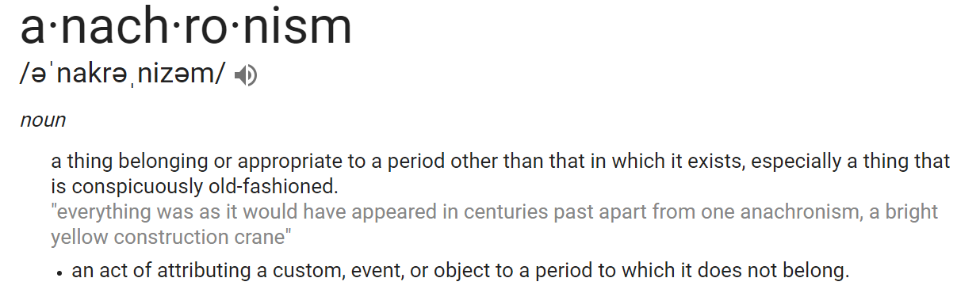

Advanced filter can be useful in the following situations:

* you want 3+ criteria in one column
* you want to do “OR” between columns

**Hands on exercise:**

* Torture yourself experimenting with advanced filter. When you are sufficiently frustrated, go back to the regular filter. Try to do an OR between columns.

**file: 099-advanced-filter**

**video: 099-advanced-filter**

## Find & replace

Find and replace are great. Find helps you find data quickly. Replace helps you find and replace certain data. You can also use “find” in many other applications.

**Hands on exercise:**

* Replace every occurrence of “college” with “university”

**file: 100-find-replace**

**video: 100-find-replace**

# Exercises - Ninja Level 7

## Hands-on exercise #1

**How popular is your first name?** The Social Security administration in the United States keeps lists of the names given to children at birth. You can Google “**social security baby names**” or go to [this link](https://www.ssa.gov/oact/babynames/) and [this link](https://www.ssa.gov/oact/babynames/limits.html). Download the national data, or use the “101-baby-names-social-security” file provided in our files, then **determine how many people were also given your name** in the year you were born.

**files:**

* **101-hands-on-01**
* **101-baby-names-social-security.zip**

**video: 101-hands-on-01**

## Hands-on exercise #2

**How popular is your last name?** The US Census keeps track of who has what last name. Download the data yourself [here](https://www.census.gov/topics/population/genealogy/data/2010_surnames.html), or use the “**102-surnames-2010Census**” in our course files. Import the data then see if you can **find your last name in the data.**

**files:**

* **102-hands-on-02**
* **102-surnames-2010Census.csv**

**video: 102-hands-on-02**

## Hands-on exercise #3

Out of 216,931 Jeopardy! questions, 219 records mention “Wilde” in the question. **Filter** the records to only display only those records.

**files:**

* **103-hands-on-03**
* **103-jeopardy.csv**

**video: 103-hands-on-03**

## Hands-on exercise #4

Out of 216,931 Jeopardy! questions and answers:

* **Filter** the records to only display the 778 records that
  + mention “?lympi*” in the question
* **Filter** the records to only display the 13 records that
  + contain “Innsbruck” as the answer
* **Filter** the records to only display the 11 records that
  + mention “?lympi*” in the question
  + contain “Innsbruck” as the answer
* **Filter** the records to only display the 2 records that
  + do not mention “?lympi*” in the question
  + contain “Innsbruck” as the answer

**files:**

* **104-hands-on-04**
* **104-jeopardy.csv**

**video: 104-hands-on-04**

## Hands-on exercise #5

[Gapminder](http://www.gapminder.org/tools/#_chart-type=bubbles) has great visualization of data. You can also [download and work with their data.](http://www.gapminder.org/data/) Using the “**105-gapminder-life_expectancy_at_birth.xlsx**” spreadsheet,

* display countries which have a **life expectancy** greater than age 75 in 2016
* use **freeze frames** to hold the column and row headings in place

**file: 105-gapminder-life_expectancy_at_birth.xlsx**

**video: 105-hands-on-05**

## Hands-on exercise #6

Using the “106-gapminder-children-per-woman-total_fertility.xlsx” file:

* **hide** the 1800 - 1999 columns
* **freeze** the column and row headings
* create a new column with the heading “Grade”
  + for each 2016 value, use **vlookup** to give a grade
    - 0 children = A
    - 2 or less children = B
    - 3 or less children = C
    - 4 or less children = D
    - 4 or more children = F

**file: 106-gapminder-children-per-woman-total_fertility.xlsx**

**video: 106-hands-on-06**

## Hands-on exercise #7

Using [Wikipedia’s List of Languages](https://en.wikipedia.org/wiki/List_of_languages_by_number_of_native_speakers) page,

* bring the table of data showing the languages spoken into Excel
* add **freeze frames** as appropriate
* **sort** the list by “fraction of world population” smallest to largest
* **filter** to display only languages spoken by 74 million or more individuals

**file: 107-hands-on-07**

**video: 107-hands-on-07**

## Hands-on exercise #8

Open the “108-hands-on-08” workbook. **Replace** all grades of 100 with 102.

***Important: you will need to change back the points possible for each assignment to 100.***

**file: 108-hands-on-08**

**video: 108-hands-on-08**

## Hands-on exercise #9

**Filter** the data using **advanced filter** to display

* avg monthly searches > 100001
* OR
* suggested bid < .10

**file: 109-hands-on-09**

**video: 109-hands-on-09**

## Hands-on exercise #10

**Filter** the data using **advanced filter** to display

* keyword contains “*xl”
* OR
* keyword contains “*want”
* OR
* keyword contains “*master”

***Important: you need to add a wildcard * character at the beginning of each word to search for any number of characters before each word.***

**file:110-hands-on-10**

**video: 110-hands-on-10**

# Progressing with data

## Overview

Review and preview; Where we’ve been and where we’re going.

**file: 111-overview**

**video: 111-overview**

## Text to columns

We have previewed this at various points, but now we will cover it officially. Using “**text to columns**” you can select text and then launch the “**text import wizard**” dialog box. This is a useful tool to use to split up data in one column and to clean data. We will pull in data from Using [Wikipedia’s List of Languages](https://en.wikipedia.org/wiki/List_of_languages_by_number_of_native_speakers) page to illustrate this.

**Hands-on exercise:** copy [Yoga Berra’s quotes](http://ftw.usatoday.com/2015/09/the-50-greatest-yogi-berra-quotes), put them into Excel, then remove the numbers.

**file: 112-text-to-columns**

**video: 112-text-to-columns**

## Flash fill

**Flash fill** recognizes patterns and then completes the pattern, filling in empty cells. To demonstrate this, we will grab statistical data from [NFL](http://www.nfl.com/stats/player).

**Hands-on exercise:** open the spreadsheet used in this video, enter the full name of one player, then use “flash fill” to enter the rest of the names.

**file: 113-flash-fill**

**video: 113-flash-fill**

## Remove duplicates

You can **remove duplicate data** using the “remove duplicates” tool from the data ribbon.

**Hands-on exercise:**

* download the spreadsheet used in this video then remove the duplicates.
* try changing the data in one row of a duplicate, then “remove duplicates” in such a way that this row with changed data is not removed.

**file: 114-remove-duplicates**

**video: 114-remove-duplicates**

## Data validation

You can **validate the data a user enters** by using the “data validation” tool from the data ribbon. Using data validation means that a user can only enter certain types of data in certain cells.

**Hands-on exercise:** create a spreadsheet; have a column labeled age only accept whole numbers; provide a message to the user telling them this, and also letting them know if they tried to enter the wrong data.

**file: 115-data-validation**

**video: 115-data-validation**

## Consolidate

Consolidate will **take data in different locations and run calculations** on that data.

**Hands-on exercise:** using the spreadsheet from this video,

* create a new sheet called “Destination”, then reference values on two different sheets, bringing those values on the two the different sheets “consolidate 1-1” & “consolidate 1-2” onto the one sheet called “Destination”.
* consolidate the count of data from 2017 & 2018

**file: 116-consolidate**

**video: 116-consolidate**

## What if - goal seek

What if analysis is the origin of spreadsheets. At Harvard Business School, Dan Bricklin created the first spreadsheet to do “what if” analysis. What if analysis is simply asking “what if” questions. **What if this happens? What if that happens?** For “goal seeking” what if analysis, we define a certain goal and then Excel figures out how numbers need to change to realize that goal.

**Hands-on exercise:** using the spreadsheet from the video, to earn a profit of $135,000 what does “Sale price course” need to be?

**file: 117-goal-seek**

**video: 117-goal-seek**

## What if - scenario

The scenario manager allows you to **create and save different scenarios.** You can then easily click between the different scenarios. You can also show a summary of the scenarios.

**Hands-on exercise:** using the spreadsheet from the video, create a scenario where price is 19, customers are 15000, and teacher royalty is 35%.

**file: 118-what-if-scenario**

**video: 118-what-if-scenario**

## What if - data table

A **data table** shows you **many possible outcomes based upon two changing inputs.** Contrast this with a **scenario** which shows you **one possible outcome based upon many changing inputs.**

**file: 119-data-table**

**video: 119-data-table**

## Forecasts

forecast sheet

**file: 120-forecasts**

**video: 120-forecasts**

# Exercises - Ninja Level 8

## Hands-on exercise #1

Go to <http://www.nfl.com/stats/player> and then click on “[complete list](http://www.nfl.com/stats/categorystats?tabSeq=0&statisticCategory=PASSING&conference=null&season=2017&seasonType=REG&d-447263-s=PASSING_YARDS&d-447263-o=2&d-447263-n=1)”. Choose the “By player position” tab. For each position, select the table of data then copy it into Excel. After that, get **all NFL players into a spreadsheet with these three columns: Name, Team, Position.**

**file: 121-hands-on-01**

**video: 121-hands-on-01**

## Hands-on exercise #2

Build a list of all of the NFL teams. Copy the teams from <https://www.nfl.com/teams>. Paste them into Excel. Use the following steps, in this order, to obtain your list:

* the text function “**find**”
* the logical function “**iferror**”
* **paste values**
* **sort**
* **remove duplicates**

**file: 122-hands-on-02**

**video: 122-hands-on-02**

## Hands-on exercise #3

Using what you have built in hands-on exercises #1 & #2, use **vlookup** to add the full team name next to each player’s name.

**file: 123-hands-on-03**

**video: 123-hands-on-03**

## Hands-on exercise #4

Using the NFL data we have been developing,

* break apart the players names using **text to columns**
* in a new column, put the players names back together using **flash fill**
* in a new column, put the players names back together using **concatenation**
* in a new worksheet, have a list of all of the player’s names **without duplicates**

**file: 124-hands-on-04**

**video: 124-hands-on-04**

## Hands-on exercise #5

Open the spreadsheet with the unemployment data for individuals above the age of 15. There are two sets of four worksheets. Use **consolidate** on each of the sets of data.

* What is the difference?
* How did this difference occur?

**file: 125-hands-on-05**

**video: 125-hands-on-05**

## Hands-on exercise #6

Use **goal seek** to determine what grade you need to get on the final to earn an “A”. After you have done that, **remove duplicates** from your contact list of friends.

**file: 126-hands-on-06**

**video: 126-hands-on-06**

## Hands-on exercise #7

Create the following **scenarios**

* one
  + 50% on the final
  + 100% on chapter 14,15,16
* two
  + 75% on the final
  + 50% on chapter 14,15,16
* three
  + 90% on the final
  + 0% on chapter 14,15,16

Show a summary when you are done.

**file: 127-hands-on-07**

**video: 127-hands-on-07**

## Hands-on exercise #8

Create a **data table** with the two inputs being your final score and your attendance score. How much class can you miss and still get an “A”?

**file: 128-hands-on-08**

**video: 128-hands-on-08**

## Hands-on exercise #9

Build the same solution as in the previous exercise but instead of using a data table, use **relative, absolute, and mixed references.**

**file: 129-hands-on-09**

**video: 129-hands-on-09**

## Hands-on exercise #10

From Yahoo Finance, [download all of the historical data for GOOG](https://finance.yahoo.com/quote/GOOG/history?p=GOOG). Using the “close” price, what is the **forecast** for this stock over the next couple of years with 95% confidence?

* hint: you will need a regular interval. Just use a single day of the week as one of your data points.
  + change the date to “custom” with “dddd” as the format
  + copy paste into notepad
  + copy paste back into excel
    - sort
    - strip out other days
      * use the “if” function to find just “Wednesday”
* Remember, when setting seasonality, there are 52 weeks in the year.

**file: 130-hands-on-10**

**video: 130-hands-on-10**

# Displaying data

## Overview

Review and preview; Where we’ve been and **where we’re going.**

**file: 131-overview**

**video: 131-overview**

## Group

We can organize our data into groups. You can group columns or rows together. When you group data, navigation appears to the left of rows or to the top of columns. You can click on these navigation elements to expand or contract your data. This allows you to **quickly reveal, or hide, groups of data.** Note of distinction: if you don’t want people to see columns, use “hide” instead.

**file: 132-group**

**video: 132-group**

## Subtotal

Automatically **calculate subtotals and grand totals** in a list for a column by using the subtotal command.

**file: 133-subtotal**

**video: 133-subtotal**

## Visually representing data

Here we once again come back to **content and form:** It’s not just what you say, it’s how you say it. **The representation of data influences the perception of data.**

Great examples of data representation:

* **Gapminder** - <https://www.gapminder.org/tools/>
* [Aaron Koblin - http://www.aaronkoblin.com/](http://www.aaronkoblin.com/)

Examples of different charts we can create:

* **pie**
  + parts of a whole
* **line**
  + data changing over time
* **column**
  + comparing quantities
* **bar**
  + like column but horizontal
* **stacked** **column**
  + like a pie chart and a column chart combined
* **stacked** **bar**
  + like stacked column but horizontal
  + two different charts convey different impressions
* **trendlines**
  + trends over time
* **sparklines**
  + small charts that occupy a single cell
* **scatter**
  + scattered dots of data

**file: 134-visual**

**video: 134-visual**

## Chart creation

When you create a chart, **what you select is crucially important.** Generally speaking, you will want to select

* **data**, without totals
* **column headers**
* **row headers**

Sometimes that means selecting non-contiguous regions. To do that

* **ctrl + click-&-drag**

If you don't like the way a chart looks when you create it, try selecting different data and creating the chart again. In this video, we will create the following charts:

* **pie**
* **line**
* **column**
* **bar**

**file: 135-chart-creation**

**video: 135-chart-creation**

## Chart creation II

Creating the following charts:

* **stacked column**
* **stacked bar**
* **donut**

You can also switch the representation of the data on the x / y axis:

* **right click a chart**
  + **change chart type**
    - column, line, pie, bar ….
  + **select data**
    - **switch row / column**
      * changes the way data is displayed

**file: 136-chart-creation-II**

**video: 136-chart-creation-II**

## Chart formatting

Pay attention to what message you are conveying with your charts. The representation of data influences the perception of data. You can **influence what message you convey with which chart you choose and how you format it.** A lot of creating charts is a trial and error process:

* create different charts until you get one you like
* try formatting options until you get the look you like

You can ROTATE 3-D pie charts.

* **click a chart**
  + plus ( **+** ) to the right
    - show/hide different aspects of the chart
* **click part of a chart**
  + delete it by pressing delete

**file: 137-chart-formatting**

**video: 137-chart-formatting**

## Chart formatting II

When formatting charts, **embrace a spirit of exploration and experimentation.** Pay attention to what you are left-clicking and right-clicking. Look at the options available. Explore and experiment until you get the look you want.

* **click a chart**
  + plus ( **+** ) to the right
    - show/hide different aspects of the chart
  + paintbrush to the right
    - change look
* **right click a chart**
  + **change chart type**
    - column, line, pie, bar ….
  + **select data**
    - switch row / column
      * changes the way data is displayed
  + **move chart**
    - new sheet
  + **format chart area**
* rotating a 3D chart

**file: 138-chart-formatting-II**

**video: 138-chart-formatting-II**

## Chart sparklines

Sparklines are **small charts that occupy a single cell.**

**file: 139-chart-sparklines**

**video: 139-chart-sparklines**

## Combo chart

Combo charts allow you to **combine two charts.** Creating a combo chart requires a few steps:

* create a chart with one column of data
* copy/paste a second column of data onto the chart
* select the chart, then change the chart type to a combo chart

You can create a secondary axis so that data of different scales can still be graphed together.

* consider including an axis title so that others can easily interpret the data.

**file: 140-combo-chart**

**video: 140-combo-chart**

## Chart trendlines

Use a trendline to **show** **the general trend of some data.** You can use trendlines with some charts. To insert a trendline, first click on your chart, then go to:

**file: 141-chart-trendlines**

**video: 141-chart-trendlines**

# Exercises - Ninja Level 9

## Hands-on exercise #1

Use “get external data from text” which will launch the “text import wizard” dialog box and then import the “142-hands-on-01.csv” data. **Chart the data. Add a trendline to it.**

***Important: make sure you just use the “close” data***

Personal anecdote: An aspect of all journeys is that, at times, they challenge and exhaust us. The word “travel” came from the word “travail”, meaning to endure hardship. On the journey, to complete the journey, you just keep going.

**file: 142-hands-on-01**

**video: 142-hands-on-01**

## Hands-on exercise #2

Open the file associated with this exercise. **Add sparklines** for the following data:

* assignments
* attendance
* quizzes

**file: 143-hands-on-02**

**video: 143-hands-on-02**

## Hands-on exercise #3

Open the file associated with this exercise. **Create two combo charts** graphing:

* one
  + unemployment
  + presidential approval
* two
  + consumer confidence
  + presidential approval

**file: 144-hands-on-03**

**video: 144-hands-on-03**

## Hands-on exercise #4

Using the spreadsheet for this exercise, **subtotal this data**:

* sport
* sales

**file: 145-hands-on-04**

**video: 145-hands-on-04**

## Hands-on exercise #5

Using the spreadsheet for this exercise, **graph the sales data.** Show the sales for each sales person by month.

**file: 146-hands-on-05**

**video: 146-hands-on-05**

# Viewing & printing

## Split window

You can **simultaneously view different areas of a spreadsheet** by splitting the spreadsheet.

* hide / unhide

**file: 147-split**

**video: 147-split**

## Multiple windows

You can also **simultaneously view different areas of a spreadsheet** by having multiple windows.

* new window
  + arrange all
  + switch windows
  + view side-by-side
    - synchronous scrolling
    - reset window position

**file: 148-m-windows**

**video: 148-multiple-windows**

## Helpful printing views

To print well in Excel, the first and most important thing you need to know is how to look at what is going to be printed. To do this, we can use the following

* view ribbon
  + **page break preview**
  + **page layout**
* page layout ribbon
  + page setup dialogue box
    - **print preview**

**file: 149-prep-print**

**video: 149-prep-print**

## Page break adjustments

When in **page break preview**, we can adjust what is going to be printed by dragging the blue lines.

**file: 150-page-break**

**video: 150-page-break**

## Including layout items

You can **include row headings, column headings, and gridlines** in your worksheets when they print.

**file: 151-layout-items**

**video: 151-layout-items**

## Exploring page setup

There are some **additional items in page setup** which we can adjust before printing:

* orientation
  + landscape
  + portrait
* fit-to
* paper size
  + letter, legal, etc
* margin
  + center

**file: 152-page-setup**

**video: 152-page-setup**

## Adding a header & footer

Before printing our worksheets, we can also **add headers and footers** by using the page setup dialog box.

**file: 153-header-footer**

**video: 153-header-footer**

## Printing & printing to file

A trick which not a lot of people know about is that you can print to a file. **Printing to a file lets you save your document as a file.** Usually this file is a PDF.

**file: 154-print-to-file**

**video: 154-print-to-file**

# Exercises - Ninja Level 10

## Hands-on exercise #1

Use **split window** to edit two different areas of the worksheet.

**file: 155-hands-on-01**

**video: 155-hands-on-01**

## Hands-on exercise #2

Using the workbook associated with this exercise,

* create four **multiple windows**
* **switch** between the windows
* **arrange all** of the windows in a tile fashion
* **hide** the third window
* **unhide** the third window
* highlight cell B4 to have
  + a yellow background color
  + a solid black border

**file: 156-hands-on-02**

**video: 156-hands-on-02**

## Hands-on exercise #3

Using the “page break preview” view, **adjust the blue dashed lines** so that your worksheet only prints on two pages.

**file: 157-hands-on-03**

**video: 157-hands-on-03**

## Hands-on exercise #4

While in “page break preview” view, **adjust the “width” and “height”** under page layout so that your worksheet only prints on two pages.

**file: 158-hands-on-04**

**video: 158-hands-on-04**

## Hands-on exercise #5

Using the workbook associated with this exercise, ensure that the following are included when printing

* **row headings**
* **column headings**
* **gridlines**

Print to a PDF file. Save this file as “159-hands-on-05.pdf”.

**file: 159-hands-on-05**

**video: 159-hands-on-05**

## Hands-on exercise #6

Using the workbook associated with this exercise, ensure that the following are included when printing

* **rows to repeat at top - the top row**
* **columns to repeat at left - the left column**
* **gridlines**

Print to a PDF file. Save this file as “160-hands-on-06.pdf”. Compare this file with “159-hands-on-05.pdf”.

**file: 160-hands-on-06**

**video: 160-hands-on-06**

## Hands-on exercise #7

Using the workbook associated with this exercise, ensure that the following are included when printing

* use .25 **margins** all around
  + adjust the top & bottom margins as necessary
* **center** the spreadsheet in the middle of the page
* include a **header**
  + left area: your name
  + center area: the icon “”
  + right area: the time & data
* include a **footer**
  + left area: file name & file location
  + right area: current page & total pages

Print to a PDF file. Save this file as “160-hands-on-06.pdf”. Compare this file with “161-hands-on-07”.

**file: 161-hands-on-07**

**video: 161-hands-on-07**

## Hands-on exercise #8

Using the workbook associated with this exercise, **adjust printing settings** so that the file prints well. Print the file to a PDF. Save the file as “162-hands-on-08”.

**file: 162-hands-on-08**

**video: 162-01-hands-on-08**

# Functions - logical

## Overview

You’re doing great! Look at how far you have come! Look at how much you have learned!

**video: 162-02-overview**

## na

Returns the error value #N/A. #N/A is the error value that means "no value is available." Use NA to **mark empty cells.** By entering #N/A in cells where you are missing information, you can **avoid the problem of unintentionally including empty cells in your calculations.**

* When a formula refers to a cell containing #N/A, the formula returns the #N/A error value.
* You can also type the value #N/A directly into a cell.
* The NA function is provided for compatibility with other spreadsheet programs.

**file: 163-na**

**video: 163-na**

## ifna

IFNA **checks to see if a value is NA**.

* if the value **is not** NA, the value of the cell checked is returned
* if the value **is** NA, the value “value_if_na” specified to be returned is returned

Syntax

* IFNA(value, value_if_na)

**file: 164-ifna**

**video: 164-ifna**

## if

The IF function is one of the most popular functions in Excel, and it allows you to make logical comparisons between a value and what you expect. In its simplest form, the IF function says: **IF(Something is True, then do something, otherwise do something else).** So an IF statement can have two results:

* if your comparison is True, then one thing
* if your comparison is False, then another thing

You can nest if statements but this isn’t recommended:

* Multiple IF statements require a great deal of thought to build them correctly and make sure that their logic can calculate correctly through each condition all the way to the end.
* Multiple IF statements can become very difficult to maintain, especially when you come back some time later and try to figure out what you, or worse someone else, was trying to do.
* Multiple IF statements require multiple open and closing parentheses (), which can be difficult to manage depending on how complex your formula becomes.

**file: 165-if**

**video: 165-if**

## iferror

Use the IFERROR function to **catch and handle errors** in a formula. IFERROR returns

* if the value **is not** ERROR, the value of the cell checked is returned
* if the value **is** ERROR, the value “value_if_error” specified to be returned is returned

Syntax

* IFERROR(value, value_if_error)
  + The argument that is checked for an error.
  + The value to return if the formula evaluates to an error.
* The following error types are evaluated: #N/A, #VALUE!, #REF!, #DIV/0!, #NUM!, #NAME?, or #NULL!

Remarks

* If Value or Value_if_error is an empty cell, IFERROR treats it as an empty string value ("").

**file: 166-iferror**

**video: 166-iferror**

## true & false

TRUE function

* **returns the logical value TRUE**
* You can use this function when you want to return the value TRUE based on a condition.
  + For example: =IF(A1=1,TRUE())
    - If the condition is met, Excel returns TRUE
    - If the condition is **not** met, Excel returns FALSE
* You can also enter the value TRUE directly into cells and formulas without using this function.
  + For example: =IF(A1=1,TRUE)
    - If the condition is met, Excel returns TRUE
    - If the condition is **not** met, Excel returns FALSE

FALSE function

* **returns the logical value FALSE**
* You can also type the word FALSE directly onto the worksheet or into the formula, and Microsoft Excel interprets it as the logical value FALSE.
* The FALSE function is provided primarily for compatibility with other spreadsheet programs.

**file: 167-true-false**

**video: 167-true-false**

## not

The NOT function will **reverse a boolean value**:

* NOT(TRUE())
  + the value will be false
* NOT(FALSE())
  + the value will be true

Use the NOT function when you want to **make sure one value is not equal to another**.

* example NOT(A1=A2)

**file: 168-not**

**video: 168-not**

## and

The AND function allows you to combine logical tests.

* The combined logical tests will return true if they are all true.
* The combined logical tests will return false if at least one of them is false.

Use the AND function to **determine if all conditions in a test are TRUE.**

**“I will go to the park if it is Wednesday AND it is sunny AND it is December.”**

**file: 169-and**

**video: 169-and**

## or

The OR function allows you to combine logical tests.

* The combined logical tests will return true if any of them are true.
* The combined logical tests will return false if all of them is false.

Use the OR function to **determine if any conditions in a test are TRUE.**

**“I will go to the park if it is Wednesday OR it is sunny OR it is December.”**

**file: 170-or**

**video: 170-or**

## xor

AND

* all conditions must be true

OR

* at least one condition must be true

XOR

* **an ODD number of conditions are true**

**file: 171-xor**

**video: 171-xor**

# Exercises - Ninja Level 11

## Hands-on exercise #1

Using the workbook associated with this exercise,

* mark the cells with empty values **#N/A**
* add afunction to the **Grand Totals**
  + have it say, “Please enter all values” if any cells are #N/A

**file: 172-hands-on-01**

**video: 172-hands-on-01**

## Hands-on exercise #2

Using the workbook associated with this exercise, use “**IF**” functions along with an “**AND**” function to display “recruit” in a cell if

* yds > 449
* td > 5
* rate > 99

Now find the same result with **filtering**.

**file: 173-hands-on-02**

**video: 173-hands-on-02**

## Hands-on exercise #3

Using the workbook associated with this exercise, determine if LA is **not equal** to NY for any given date and salesperson.

**file: 174-hands-on-03**

**video: 174-hands-on-03**

## Hands-on exercise #4

Show who will go to the beach when

* there is big surf **AND**
* it is sunny **AND**
* the temperature is moderate **AND**
* there is an offshore breeze

**file: 175-hands-on-04**

**video: 175-hands-on-04**

## Hands-on exercise #5

To belong to the Olympic Club, you need to have at least one of the following criteria:

* former Olympic athlete **OR**
* professional athlete starter **OR**
* twitter following greater than 10M **OR**
* enough wealth to purchase a $25M membership

Show who can belong to the club.

**file: 176-hands-on-05**

**video: 176-hands-on-05**

## Hands-on exercise #6

Jim is eccentric. He will only buy a car if it has an odd number of features. Use **XOR** to determine which cars would Jim be interested in buying.

**file: 177-hands-on-06**

**video: 177-hands-on-06**

# Functions - text

## Overview

You’re doing great! Look at how far you’ve come! Drop by drop, the bucket gets filled. Persistently, patiently, you are succeeding. In this section,

* we are going to progress forward and learn about **text functions**.
* In addition, you will see an example of **copying data off the web**, getting it into Excel, and working with it.
* Plus **documentation** of Excel will be covered in this video.

**file: 178-overview**

**video: 178-overview**

## Capitalization

* **lower**
* **upper**
* **proper**

**file: 179-capitalization**

**video: 179-capitalization**

## Joining text

* **concatenate**
* **concat (office 365)**
* **textjoin (office 365)**

Don’t forget “text-to-columns” for splitting text using the “import text wizard” dialog box.

**file: 180-concat**

**video: 180-concat**

## Replacing text

* **substitute**
* **replace**

**file: 181-replace-text**

**video: 181-replace-text**

## Finding text

* **find**
* **search**

**file: 182-finding-text**

**video: 182-finding-text**

## Text length

* **len**

**file: 183-text-length**

**video: 183-text-length**

## Text equality

* **exact**
* **=** (not case sensitive)

**file: 184-text-equality**

**video: 184-text-equality**

## Trimming text

* **left**
* **right**
* **mid**
* **trim**

**file: 185-trimming-text**

**video: 185-trimming-text**

# Exercises - Ninja Level 12

## Hands-on exercise #1

In the workbook associated with this exercise, use the following functions:

* **uppercase**
* **lowercase**
* **proper case**

**file: 186-hands-on-01**

**video: 186-hands-on-01**

## Hands-on exercise #2

In the workbook associated with this exercise, break a sentence apart into single words then use the following function:

* **concatenate**

**file: 187-hands-on-02**

**video: 187-hands-on-02**

## Hands-on exercise #3

In the workbook associated with this exercise, use the following functions:

* **substitute**
* **replace**

**file: 188-hands-on-03**

**video: 188-hands-on-03**

## Hands-on exercise #4

In the workbook associated with this exercise, use the following functions:

* **find** (case sensitive)
* **search**

**file: 189-hands-on-04**

**video: 189-hands-on-04**

## Hands-on exercise #5

In the workbook associated with this exercise, use the following function:

* **len**

**file: 190-hands-on-05**

**video: 190-hands-on-05**

## Hands-on exercise #6

In the workbook associated with this exercise, use the following function:

* **exact**
* **=** (not case sensitive)

**file: 191-hands-on-06**

**video: 191-hands-on-06**

## Hands-on exercise #7

In the workbook associated with this exercise, create your own poetry by using the following functions:

* **left**
* **right**
* **mid**
* **trim**

**file: 192-hands-on-07**

**video: 192-hands-on-07**

# Functions - date & time

## Dates & times

Dates are stored as sequential serial numbers so they can be used in calculations. By default, **December 31, 1899 is serial number 1**, and January 1, 2008 is serial number 39448 because it is 39,448 days after January 1, 1900.

* **errors in MS Excel & Office 365**

**file: 193-dates-times**

**video: 193-dates-times**

## Current date time

We can **retrieve** the current date & time by using these functions:

* **now**
* **today**

**file: 194-current**

**video: 194-current**

## Created date time

We can **create** a certain date and time using these functions:

* **date**
* **time**

**file: 195-create**

**video: 195-create**

## Extracting date time

We can **extract** a certain aspect from a date & time using these functions:

* **day**
  + returns the day of the month
* **hour**
  + returns the hour
* **minute**
  + returns the minute
* **second**
  + returns the second
* **weekday**
  + returns the day of the week
* **year**
  + returns the year
* **month**
  + returns the month
* **weeknum**
  + returns the week in the year

**file: 196-extract**

**video: 196-extract**

## Finding durations

We can find the **duration** from one point in time to another using these functions and one formula:

* **days**
* **days360**
* **networkdays**
* **yearfrac**
* **=time2-time1**

**file: 197-durations**

**video: 197-durations**

## Finding the future

We can find a **future** point in time using these functions:

* **edate**
* **eomonth**
* **=time1+number**

**file: 198-the-future**

**video: 198-the-future**

# Exercises - Ninja Level 13

## Hands-on exercise #1

Use the following functions:

* **now**
* **today**
* **date**
* **time**

**file: 199-hands-on-01**

**video: 199-hands-on-01**

## Hands-on exercise #2

Use the following functions to **extract** a certain aspect of a date:

* **day**
  + returns the day of the month
* **hour**
  + returns the hour
* **minute**
  + returns the minute
* **second**
  + returns the second
* **weekday**
  + returns the day of the week
* **year**
  + returns the year
* **month**
  + returns the month
* **weeknum**
  + returns the week in the year

Bonus: Download OBS. Create a video explaining the differences between these functions. Upload to YouTube. Tweet the link. [Tag me](https://twitter.com/Todd_McLeod) in the Tweet.

**file: 200-hands-on-02**

**video: 200-hands-on-02**

## Hands-on exercise #3

**Format** the date in the spreadsheet so that it appears in the following ways:

* **Monday, September 25, 2017**
* **09/25/2017 2:05:24 PM**
* **09/25/2017 14:05:24**
* **02:05:24 PM**
* **14:05:24**
* **2:05 PM**
* **14:05**
* **Monday**
* **September**
* **17**
* **2017**
* **PM**

Bonus: Create a video showing how to do this date & time formatting. Upload to YouTube. Tweet the link. [Tag me](https://twitter.com/Todd_McLeod) in the Tweet.

**file: 201-hands-on-03**

**video: 201-hands-on-03**

## Hands-on exercise #4

Find the **duration** between two dates using the following functions and formula:

* **days**
* **days360**
* **networkdays**
* **yearfrac**
* **=time2-time1**

Bonus: Create a video showing how to do this. Upload to YouTube. Tweet the link. [Tag me](https://twitter.com/Todd_McLeod) in the Tweet.

**file: 202-hands-on-04**

**video: 202-hands-on-04**

## Hands-on exercise #5

Find a **future** point in time using the following functions:

* **edate**
* **eomonth**
* **=time1+number**

Bonus: Create a video showing how to do this. Upload to YouTube. Tweet the link. [Tag me](https://twitter.com/Todd_McLeod) in the Tweet.

**file: 203-hands-on-05**

**video: 203-hands-on-05**

## Hands-on exercise #6

Find two **random future points** in time, and then find the **duration** between them. Bonus: Create a video showing how to do this. Upload to YouTube. Tweet the link. [Tag me](https://twitter.com/Todd_McLeod) in the Tweet.

**file: 204-hands-on-06**

**video: 204-hands-on-06**

# Functions - lookup & reference

## Overview

You’re doing great. Look at how far you’ve come! In this section, we are going to cover:

* **vlookup**
* **hlookup**
* **index**
* **match**
* **choose**
* **transpose**
* **column**
* **columns**
* **row**
* **rows**
* **address**
* **indirect**
* **offset**
* **formulatext**
* **hyperlink**

**file: 205-overview**

**video: 205-overview**

## vlookup

This is a review of **vlookup** which allows us to **look a value up in a table of values, then return an associated value.** For instance, in a gradebook a student might have a score of 84%. I could use vlookup to then insert “B” next to the student’s grade.

**file: 206-vlookup**

**video: 206-vlookup**

## hlookup

The function **hlookup** **works just like vlookup.** Instead of using a table of references organized into a column, however, it uses a table to reference organized into rows.

**file: 207-hlookup**

**video: 207-hlookup**

## index

Based upon some **index (row)** in a table of data, we can return an associated value.

**file: 208-index**

**video: 208-index**

## match

The match function allows us to **find the index (row)** of an item in a table of data. We can use match in conjunction with index to look for an item in a list of data, instead of just entering the items index (row) number.

**file: 209-match**

**video: 209-match**

## choose

The choose function allows us to **choose an item in a list of items.** This function is lame.

**file: 210-choose**

**video: 210-choose**

## transpose

We can use the transpose function to **transpose data.** To do this, however, we have to understand how [arrays](https://support.office.com/en-us/article/Guidelines-and-examples-of-array-formulas-7d94a64e-3ff3-4686-9372-ecfd5caa57c7) work in Excel. **Arrays** are also pretty lame. It is good to know about them, though, in case you come across them.

**file: 211-array-transpose**

**video: 211-array-transpose**

## row(s) column(s)

The row, rows, column, and columns functions give us **information** about the location of a row or column, and how many rows or columns are in a selection.

arrays in excel

**file: 212-row-column**

**video: 212-row-column**

## references

There are a few last functions in the Excel “lookup and reference” area which are good to know about:

* **address**
* **indirect**
* **offset**
* **formulatext**
* **hyperlink**

**file: 213-references**

**video: 213-references**

# Exercises - Ninja Level 14

## Hands-on exercise #1

Add letter grades to the gradebook using

* **vlookup**
* **hlookup**

**file: 214-hands-on-01**

**video: 214-hands-on-01**

## Hands-on exercise #2

Use **vlookup** to return the following scores:

* student 5’s score on assignment 5
* student 3’s score on assignment 7
* student 7’s score on assignment 3

**file: 215-hands-on-02**

**video: 215-hands-on-02**

## Hands-on exercise #3

Use **hlookup** to return the following scores:

* student 5’s score on assignment 5
* student 3’s score on assignment 7
* student 7’s score on assignment 3

**file: 216-hands-on-03**

**video: 216-hands-on-03**

## Hands-on exercise #4

Use the **index** function to return the percentage score for student 7.

**file: 217-hands-on-04**

**video: 217-hands-on-04**

# Functions - information

## info

Returns **info** about the current operating environment.

**file: 218-info**

**video: 218-info**

## cell

Returns **cell info** about the formatting, location, or contents of a cell.

**file: 219-cell**

**video: 219-cell**

## iseven & isodd

Returns whether or not a value is **even** or **odd**.

**file: 220-even-odd**

**video: 220-even-odd**

## na & isna

The function **na** returns the error value **#N/A**. The function **isna** checks whether or not a value is #N/A.

**file: 221-na-isna**

**video: 221-na-isna**

## iserror & iserr

The function **iserror** returns TRUE if the value is any error value. The function **iserr** returns TRUE if the value is any error value except #N/A

**file: 222-iserror-iserr**

**video: 222-iserror-iserr**

## Checking contents 1

These functions check the contents of a cell:

* **isblank**
* **isformula**
* **isref**
  + returns true if the reference is a valid reference

**file: 223-contents-1**

**video: 223-contents-1**

## Checking contents 2

These functions check the contents of a cell:

* **islogical**
  + returns true if the value is a boolean (true or false)
* **isnontext**
* **isnumber**
* **istext**

**file: 224-contents-2**

**video: 224-contents-2**

## Top 10 functions

Here are the top 10 functions [according to Microsoft](https://support.office.com/en-us/article/Excel-functions-by-category-5f91f4e9-7b42-46d2-9bd1-63f26a86c0eb):

* **SUM**
  + super great
  + what about:
    - **average**
    - **count**
    - **counta**
    - **max**
    - **min**
* **IF**
  + super great
* LOOKUP
  + We strongly recommend using VLOOKUP or HLOOKUP instead
* **VLOOKUP**
  + super great
* MATCH
  + given an entry, find the index position
* INDEX
  + given an index (row) position, return a value in a column
* CHOOSE
  + super lame - choose from a manually entered list
* DATE
  + create a date; now() is better imho as it retrieves the date
* **DAYS**
  + number of days between two dates
* FIND
  + find a string in another string

**file: 225-top-10**

**video: 225-top-10**

# Exercises - Ninja Level 15

## Hands-on exercise #1

Display the **directory path** and **filename path** of the worksheet.

**file: 226-hands-on-01**

**video: 226-hands-on-01**

## Hands-on exercise #2

Get a link to a webpage so that the webpage will open to some content in the middle or bottom section of the webpage. Insert that link into a spreadsheet two ways, using:

* **insert link**
* **hyperlink function**

**file: 227-hands-on-02**

**video: 227-hands-on-02**

## Hands-on exercise #3

Determine which of the values in the last column **is a formula**.

**file: 228-hands-on-03**

**video: 228-hands-on-03**

## Hands-on exercise #4

Complete the **steps** listed in the worksheet.

**file: 229-hands-on-04**

**video: 229-hands-on-04**

# Full completion

## Overview

You’re doing great! **Look at how far you’ve come!** Here is what we have covered, and what we will be learning next!

**file:**

* **000-func-index**
* **230 image files**

**video: 230-overview**

## Custom views

You can save a **custom view** of a spreadsheet in custom views. This allows you to easily switch back to a certain view of your worksheet.

**file: 231-custom-views**

**video: 231-custom-views**

## Conditional formatting

You can use **conditional formatting** to format cells based upon certain criteria. This is a great great tool!

**file: 232-conditional-formatting**

**video: 232-conditional-formatting**

## Objects & equations

You can use the **equation** and **object** drop-down menus from the insert ribbon to insert equations and other objects like old Powerpoint slides and photoshop images.

**file: 233-objects-equations**

**video: 233-objects-equations**

## Selection pane

The **selection pane** will help you select a specific object on a page.

**file: 234-selection-pane**

**video: 234-selection-pane**

## Translating

The **translate** function in Excel doesn’t work all that well, but it does work some of the time.

**file: 235-translating**

**video: 235-translating**

## Proofing

The proofing tools include a spell checker and thesarus. It is always good to **spell check your work before sharing it with others.**

**file: 236-proofing**

**video: 236-proofing**

## Insights

The insights “**smart lookup**” button allows you to quickly look a subject up from your spreadsheet and receive information from the www right in your spreadsheet.

**file: 237-insights**

**video: 237-insights**

# Exercises - Ninja Level 16

## Hands-on exercise #1

Create the following four **custom views**:

* one
  + default; as the spreadsheet is when you open it
* two
  + normal view
  + columns C,D,E,F hidden
* three
  + all of the above and
  + don’t show gridlines, headings, formula bar
  + show gridlines, headings, top row, and left column when printing
* four
  + all of the above and
  + header
    - left side - your name
    - middle - icon
    - right side - date
  + footer
    - left side - file path location
    - right side - page X of Y
  + background image
    - any picture you like

**file: 238-hands-on-01**

**video: 238-hands-on-01**

## Hands-on exercise #2

Use **conditional formatting** to highlight students in the gradebook such that

* “talk to” worksheet
  + any student who has less than 70.00% in the class
* “congratulate” worksheet
  + top 20% of students

**file: 239-hands-on-02**

**video: 239-hands-on-02**

## Hands-on exercise #3

Using the **selection pane**, have the items on the worksheet stacked in this order:

* heart
* sun
* star
* lightning bolt

**file: 240-hands-on-03**

**video: 240-hands-on-03**

## Hands-on exercise #4

**Translate** the phrases on the worksheet. Insert the translated phrase into the worksheet while also keeping the original language. The poem [“In My Good Death”](https://www.thesunmagazine.org/issues/418/in-my-good-death) is used for tranlsation.

**file: 241-hands-on-04**

**video: 241-hands-on-04**

## Hands-on exercise #5

Proof the worksheet for spelling errors. **Fix the spelling errors.**

**file: 242-hands-on-05**

**video: 242-hands-on-05**

## Hands-on exercise #6

Use **insights** to lookup information about **Stanislav Petrov**. This is an [interesting webpage](http://nsarchive2.gwu.edu/nukevault/ebb371/), as are the pictures associated with this exercise.

**file: 243-hands-on-06**

**video: 243-hands-on-06**

# Office 365

## Cloud based apps

Office 365 is a cloud based app. Cloud based apps are also known as “Software as a Service”. There are three categories here:

* Infrastructure as a Service (IaaS)
  + the hardware upon which **you** can install software
* Platform as a Service (PaaS)
  + the hardware with some basic software
* Software as a Service (Saas)
  + the hardware with all of the software

Cloud based services allow businesses to outsource IT work. A business can use IaaS and not have to buy and manage its own servers. A business can use PaaS and outsource even more of the management of computers. A business can use SaaS and outsource even more of the management of the computers. With cloud based apps (SaaS) like Office 365, you do not have to install Microsoft Office on a local machine to use Microsoft Office. **All you have to do is have a browser that can connect to the internet and you can use cloud based apps like Office 365.**

**video: 244-cloud-based-apps**

## MS Office vs Office 365

**MS Office is more robust than Office 365**. Compare the options in the ribbons:

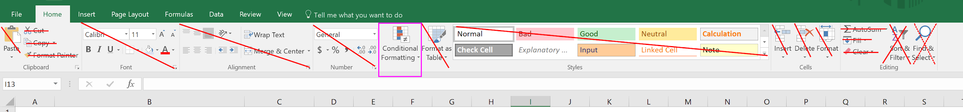

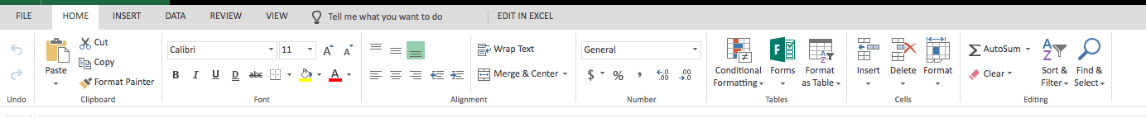

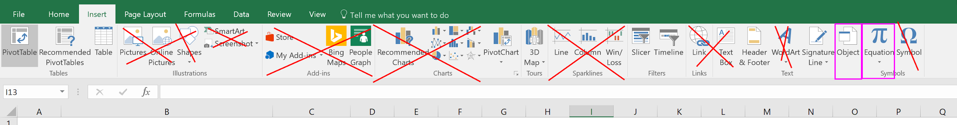

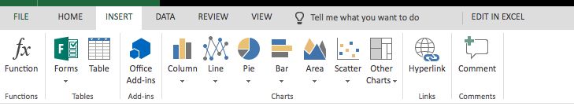

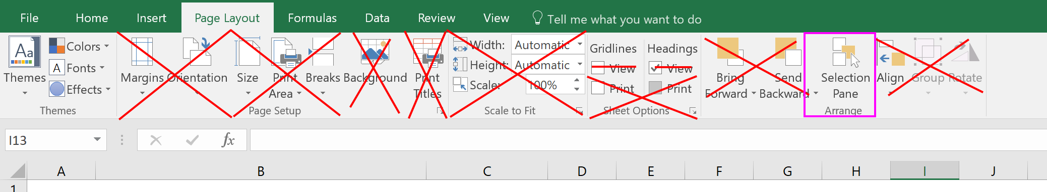

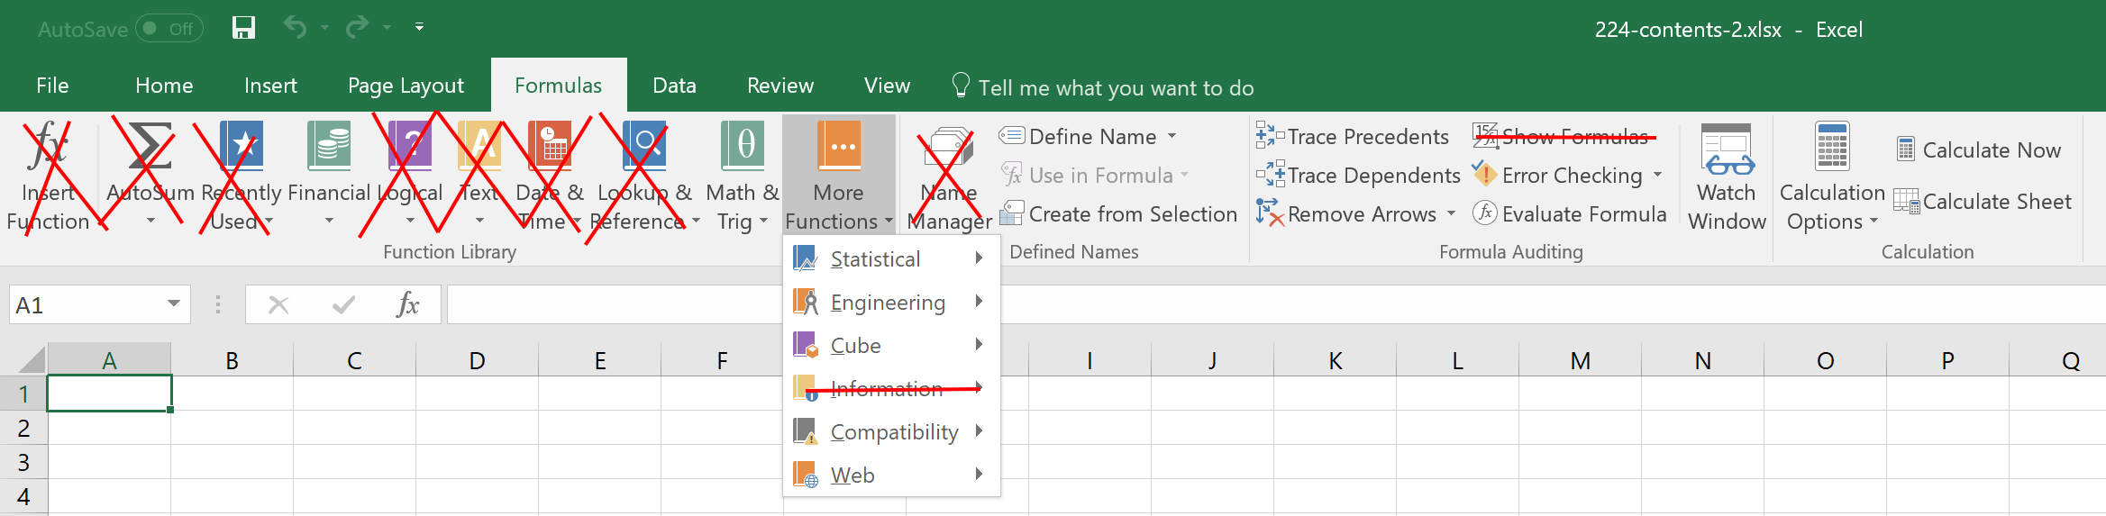



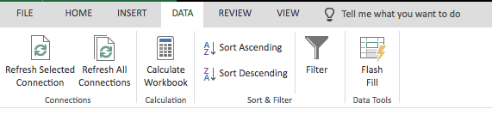

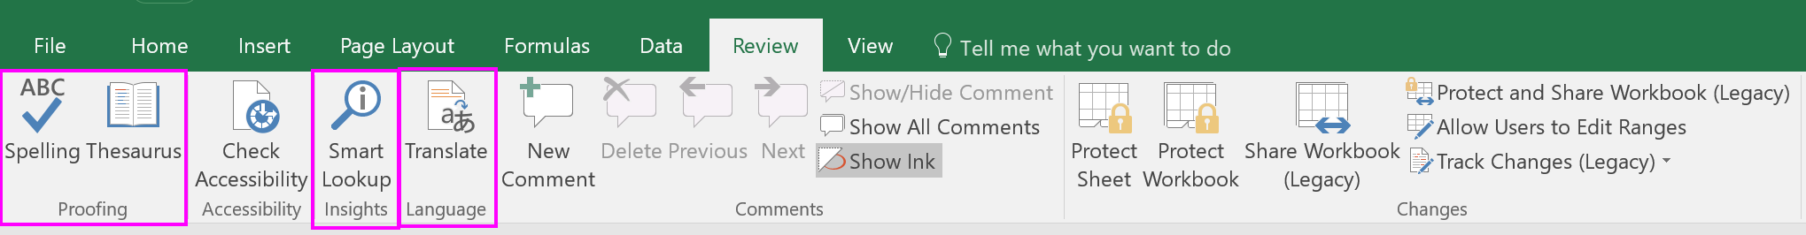

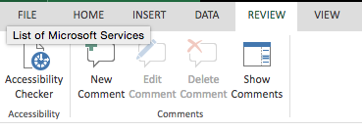

There is no spell checker!

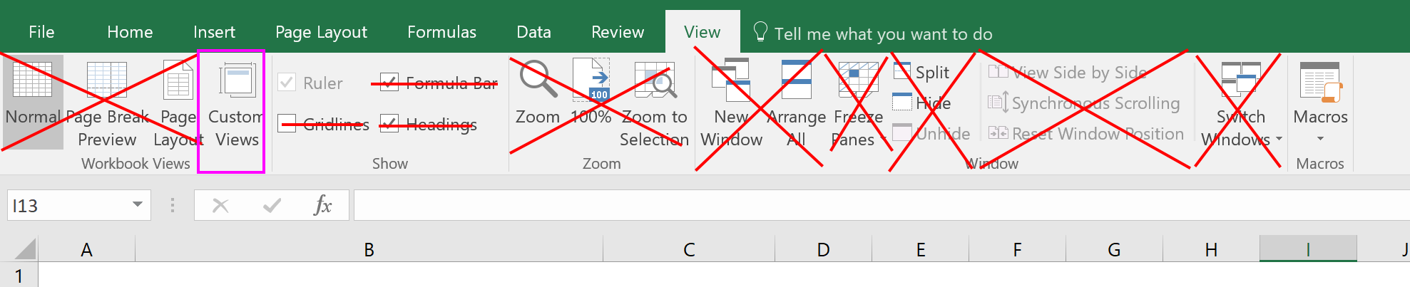

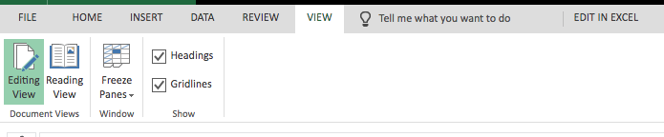

**video: 245-ms-office-vs-office-365**

## Functions and charting

**Totaling data**, and **creating a chart,** using Excel in Office 365.

**file: 246-functions-and-charting**

**video: 246-functions-and-charting**

## vlookup

Using **vlookup** in Office 365. Notice how conditional formatting is verrrrry limited. Office 365 is amazing, but Google Drive is even better.

**file: 247-vlookup**

**video: 247-vlookup**

# Exercises - Ninja Level 17

## Hands-on exercise #1

Create a **pie chart** for “begin 1” and a **line chart** for “begin 2” in Excel Office 365.

**file: 248-hands-on-01**

**video: 248-hands-on-01**

## Hands-on exercise #2

Use **hlookup** to determine student grades.

**file: 249-hands-on-02**

**video: 249-hands-on-02**

# Google Drive

## Introduction

Google drive is **Google’s SaaS online office application software,** equivalent to Office 365 but better than Office 365.

**video: 250-google-drive**

## Functions & charting

Here is how to insert a function and create a chart in **Google Drive Sheets.**

**file:**

* **251-functions-and-charting**
* [**here is the Google Sheets file I created**](https://docs.google.com/spreadsheets/d/1rxgeKa6G8tJmt_HUqV05D1Q2oSPHZt8E66pFkxaw9oQ/edit?usp=sharing)

**video: 251-functions-and-charting**

## vlookup

Using **vlookup** in Google Drive Sheets.

**file:**

* **252-vlookup**
* [**252-vlookup-online**](https://docs.google.com/spreadsheets/d/1LZKFFocyVnWtimCQbdPaSe5yPCB01nx9bpdGfFAXhqc/edit?usp=sharing)

**video: 252-vlookup**

## forms

Here is how to create a **Google Drive Form.**

**file:**

* [**253-form (click on this link to complete a form sharing your thoughts on this course. What was done well? What can be improved in future courses?)**](https://goo.gl/forms/fJNQil2BGwuNCWqT2)

**video: 253-form**

## quizzes

Here is how you **make a quiz** using Google Drive Form.

**file:** [**254-quiz**](https://goo.gl/forms/Mqv4xnNwfvX5tWxq2)

**video: 254-quiz**

## Google trends

Here is **mind blowing information.** Just your ordinary average every-day major league computer science results.

**video: 255-google-trends**

# Exercises - Ninja Level 18

## Hands-on exercise #1

Create a **pie chart** for “begin 1” and a **line chart** for “begin 2” in Google Drive.

**file:**

* **256-hands-on-01**
* [**here is my Google Sheet**](https://docs.google.com/spreadsheets/d/1WrrWYhNMWsHm1JoY5LeMKA4DgNe_CZJwpq_dfBpTKcs/edit?usp=sharing)

**video: 256-hands-on-01**

## Hands-on exercise #2

Use **hlookup** to determine student grades.

**file:**

* **257-hands-on-02**
* [**here is my Google sheet**](https://docs.google.com/spreadsheets/d/15HeW30w1kEIprT4I6DshOGS2n1MdLFy0XHJfaWBl-f0/edit?usp=sharing)

**video: 257-hands-on-02**

## Hands-on exercise #3

Create a **form** and send it to me via a [Twitter](https://twitter.com/Todd_McLeod) message.

**file:** [**here is the form I created**](https://goo.gl/forms/cGmI25hVoumHR6wK2)

**video: 258-hands-on-03**

# Good to know

## Protecting yourself online

There are steps you can take to **keep yourself safe online.** These things are great to know about!

* freeze your credit
  + experian
  + transunion
  + equifax
* password manager
  + [lastpass](https://www.lastpass.com/)
  + at least 5 random words and then some numbers and a symbol
* use credit credits
  + [fair credit billing act](https://en.wikipedia.org/wiki/Fair_Credit_Billing_Act#Other_regulations_of_the_FCBA)
* quickbooks online
* accountant
  + $300 - 1000
* don’t share personal info

**file: 259-safe-online**

**video: 259-safe-online**

## Scrolling sheets

You can **scroll through your worksheets** by clicking the arrow button down at the bottom left. This was covered briefly in one other video. This, along with an exploration of the bottom status bar area, is included here just to be thorough.

**file: 260-scroll-sheets**

**video: 260-scroll-sheets**

## File extensions

File extensions were discussed briefly in one other video. This is included here to be thorough. If this is redundant, please skip this video.

* **file extensions**
* showing file extensions in Windows
* telling your computer which software to use to open files of a certain extension
* file extensions
  + show your file extensions
  + download an image from the web
  + see what software opens that file
  + use your web browser to open that image file
* associate csv with excel

**file: 261-file-extensions**

**video: 261-file-extensions**

## Ethnocentricity

The **world map** has been ethnocentric. Ethnocentricity means evaluating other peoples and cultures according to the standards of one's own culture. In our global community, it’s important to identify and be aware of biases.

**video: 262-ethnocentricity**

## Where we’ve been

**Look at what we’ve covered!**

**file: 263 image files**

**video: 263-where-weve-been**

# Congratulations

You have done great work - the greatest work. You have taken steps to create a better life for yourself, and for others. As an individual improves their own life, they improve the world. The skills you are acquiring are some of the most valuable skills demanded today: knowing how to use Excel. Congratulations. You have done great.

**Next Steps:**

* [Follow me on Twitter](https://twitter.com/Todd_McLeod)
  + <https://twitter.com/Todd_McLeod/status/908342249347354625>
* Intermediate Excel
* Advanced Excel
* Comprehensive Excel
* Create your own course

**video: 264-congratulations**

# *** *** *** ADVANCED EXCEL *** *** ***

# Financial functions I

## Financial health

There are several areas in life where it is important to maintain good health:

* physical health
* social / family health
* mental / emotional health
* **financial health**

This section will show you how to use, and understand, financial functions.

**video: 265-financial-health**

## Time is money

Money and time have a relationship. A dollar today is not worth a dollar tomorrow. There is interest and inflation. If I invest a dollar, I expect to get interest. When I was eighteen, $5.00 would buy you lunch. Today you need $10.00 to buy lunch. This is the **time value of money.** The value that money has over time is determined by interest and inflation. Interest is the cost of money. Inflation is the increase in prices (and deflation is the decrease in prices). When we talk about “real” figures, we are taking inflation into consideration; adjusting our equations to nullify the effect of inflation. Good definitions to know:

* **inflation** - increase in prices over time
  + deflation - decrease in prices over time
* **interest** - cost of money
* **“real” money** - inflation has been nullified
  + for example: real rate of return
    - interest 10%
    - inflation 4%
    - real rate of return 6%

**file:** [**http://www.investopedia.com/articles/03/082703.asp**](http://www.investopedia.com/articles/03/082703.asp)

**video: 266-time-is-money**

## Future value I

What is something worth in the future? This is the future value. The future value is **the value of an amount(s) in the future.** It measures the nominal future sum of money that a given sum of money is "worth" at a specified time in the future assuming a certain interest rate, or more generally, rate of return. This video shows the manual way of calculating future value.

**file:** [**http://www.investopedia.com/articles/03/082703.asp**](http://www.investopedia.com/articles/03/082703.asp)

**video: 267-future-value**

## Future value II

This video shows the automated way to calculate future value using **the excel FV function.**

**file:** [**http://www.investopedia.com/articles/03/082703.asp**](http://www.investopedia.com/articles/03/082703.asp)

**video: 268-future-value-II**

## Future value III

This video shows how to **calculate the future value when you are also adding to the investment every period** with a period payment.

**video: 269-future-value-III**

## Future value IV

Here is how to **manually calculate the future value** with a payment to the investment every period.

**video: 270-future-value-IV**

## Present value

What is something worth right now? This is the present value. The present value is **the amount a future payment(s) is worth now.** We must use some interest rate to determine the present value. This interest rate is called the discount rate.

**file:** [**http://www.investopedia.com/articles/03/082703.asp**](http://www.investopedia.com/articles/03/082703.asp)

**video: 271-present-value**

## Present value II

Here is how to use the PV function in Excel to calculate the present value.

**file:** [**http://www.investopedia.com/articles/03/082703.asp**](http://www.investopedia.com/articles/03/082703.asp)

**video: 272-present-value-II**

# Exercises - Ninja Level 19

## Hands-on exercise #1

Calculate this manually, only using formulas you write and don’t use Excel functions. Create a schedule of 30 years that shows **the future value of an investment** if you invested $100,000 today and earned 11% interest every year.

**file: 273-hands-on-01**

**video: 273-hands-on-01**

## Hands-on exercise #2

Using the spreadsheet from the previous exercise, in the column next to your manual calculations, use Excel’s **FV function** to get the same results.

**file: 274-hands-on-02**

**video: 274-hands-on-02**

## Hands-on exercise #3

Calculate this manually, only using formulas you write and don’t use Excel functions. Create a schedule of 30 years that shows **the future value of an investment** if you invested $100,000 today, contributed an additional $10,000 to the investment every year after that, and earned 11% interest every year. Here is what your schedule of contributions should look like:

* year 0 $100,000
* year 1 $10,000
* year 2 $10,000
* year …
* year 30 $10,000

**file: 275-hands-on-03**

**video: 275-hands-on-03**

## Hands-on exercise #4

Using the spreadsheet from the previous exercise, in the column next to your manual calculations, use Excel’s **FV function** to get the same results.

**file: 276-hands-on-04**

**video: 276-hands-on-04**

## Hands-on exercise #5

If someone offered to pay your heirs $2,850,844,155,882.65 in 200 years for a job that would take you 6 months to complete, what hourly wage would be you earning if you worked 40 hours per week for 26 weeks? Use a **discount rate** of 11.5% to calculate the **present value**.

**file: 277-hands-on-05**

**video: 277-hands-on-05**

## Hands-on exercise #6

If you invested $1,000 today, earned 11.5% interest on it, and there was 4% inflation, what would your investment be worth in 200 years in **real dollars**?

**file: 278-hands-on-06**

**video: 278-hands-on-06**

## Hands-on exercise #7

What is the **present value** of $1,000,000 30 years from now assuming a discount rate of 7%?

**file: 279-hands-on-07**

**video: 279-hands-on-07**

# Financial functions II

## Loan payment

The pmt function allows us to **calculate that payment on a loan** (or an annuity, in which case the payment would be to you, the lender).

**file: 280-payment**

**video: 280-payment**

## Loan amortization

To amortize a loan is to pay it off. We can create **a schedule which shows the loan being paid off**. This is known as an amortization schedule.

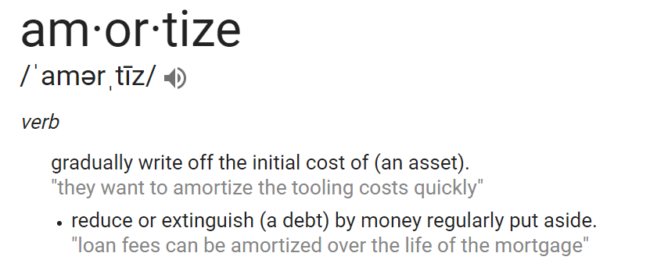

**file: 281-amortize**

**video: 281-amortize**

## Annuity payment

Here is an example of **a loan where you are the lender** - an annuity. The ipmt function is also covered in this video. The ipmt function allows you to **calculate the interest payment.**

**file: 282-annuity**

**video: 282-annuity**

## Payment & interest

How to use the ppmt & ipmt to calculate the **payment and interest for a given period** of a loan.

**file: 283-payment**

**video: 283-payment**

## NPV

In finance, the net present value (NPV) is a measurement of profit calculated by subtracting the present values (PV) of **cash outflows** (including initial cost) from the present values of **cash inflows** over a period of time. NPV is used for making a decision as to whether or not a project should be undertaken.

**file: 284-npv**

**video: 284-npv**

## IRR

The **internal rate of return (IRR)** is a method of calculating rate of return. The term internal refers to the fact that its calculation does not involve external factors, such as inflation or the cost of capital. IRR is also used for making a decision as to whether or not a project should be undertaken. NPV is more popular in academia; IRR is more popular in industry.

**file: 285-irr**

**video: 285-irr**

# Exercises - Ninja Level 20

## Hands-on exercise #1

Calculate the **payment** on the following mortgage:

* amount: $100,000
* rate: 4.25%
* term: 30 years
* period: monthly

**file: 286-hands-on-01**

**video: 286-hands-on-01**

## Hands-on exercise #2

Create an **amortization schedule** for the following mortgage:

* amount: $100,000
* rate: 4.25%
* term: 30 years
* period: monthly

**file: 287-hands-on-02**

**video: 287-hands-on-02**

## Hands-on exercise #3

It is your birthday. You are now 65 years old. Statistics say you will live to 79 years. You think you are above average, however, and would like to plan to live to 90 years. You have $3.65M in an investment which returns 4.5% annually. **How much can you take out every month,** starting at the end of this month, if you want to use only $3M of your investment by the time you turn 90. You will take this money out over 300 monthly periods. Create an amortization schedule showing balances as you make withdrawals.

**file: 288-hands-on-03**

**video: 288-hands-on-03**

## Hands-on exercise #4

In the spreadsheet associated with this exercise you will find a stream of cash flows for each month. Using **NPV** analysis, is this project worth undertaking?

**file: 289-hands-on-04**

**video: 289-hands-on-04**

## Hands-on exercise #5

In the spreadsheet associated with this exercise you will find an investment opportunity. Using **IRR** analysis, will this investment earn a rate of return greater than the American stock market average of 7%?

**file: 290-hands-on-05**

**video: 290-hands-on-05**

# Pivot tables

## Introduction

Pivot tables are super-powerful. So many people don't know how to use pivot tables. In just a few short minutes, this video will get you going with pivot tables. A pivot table allows you to **pivot your views on your data**. [Tableau software](https://www.tableau.com/) is where you want to go for more advanced data analytics.

**file: 291-intro-to-pivot-tables**

**video: 291-intro-to-pivot-tables**

## Pivoting your data

The purpose of computers is to **take data and turn it into information.** Pivot tables empower us to take a lot of data and quickly get information. One of the greatest challenges with pivot tables is knowing what questions to ask. **When you have a table of data, what kind of information can you extract from that data?** Again, embracing the spirit of exploration and **experimentation is the key to discovering information.** Here are several examples of interesting views of our data. If you are anything like me, when I first learned pivot tables I was like, “Wait a minute! Can you do that again? And again? And again? Slow it down.” Creating collapsible groups was briefly covered. We will cover this more again in another video.

**file: 292-pivot-your-data**

**video: 292-pivot-your-data**

## Data into information

We use pivot tables to turn data into information. When you have a table of data, it can often be challenging to know what information we can extract from that data. In this video, **we continue our exploration of taking our data and turning it into information using pivot tables.**

**file: 293-data-into-information**

**video: 293-data-into-information**

## Adding information to a table

Sometimes pivot tables don’t provide all of the information we need. We can use other Excel skills, like our knowledge of **vlookup**, to help us complete our tables of information.

**file: 294-additional-info**

**video: 294-additional-info**

## Refreshing pivot tables

When the underlying data of a pivot table changes, the pivot table does not automatically change. **To update a pivot table, you must manually refresh it.** This video explains all of this and shows you what to do: right-click your pivot table and choose “refresh data.”

**file: 295-refreshing**

**video: 295-refreshing**

## Nesting with pivot tables

You can create nested data in pivot tables. This allows you to **drill down and see underlying data.** To create nested data, add multiple items to the “row” or “column” areas in the PivotTable builder. When you nest items, you need to have items which are logically connected. For example:

* year, quarter, month, week
* region, state, city, zip code

**file: 296-nesting**

**video: 296-nesting**

## Grouping in pivot tables

Learn how to group your data in pivot tables: right click a row or column label in your pivot table, then choose “group.”

**file: 297-grouping**

**video: 297-grouping**

## Using slicers in pivot tables

A slicer is a visual interface for filtering data in a table. We can use slicers to **visually filter our data.** Slicers can also be applied to regular tables.

**file: 298a-slicers**

**video: 298a-slicers**

## Using timelines in pivot tables

A timeline is a slicer which lets you slice by time. We can use timelines to **visually filter our data.**

**file: 298b-timeline**

**video: 298b-timeline**

## Creating pivot charts

We can build **charts based upon pivot tables.** When we do this, the chart is connected to the pivot table. The chart is known as a pivot chart. When the pivot table is refreshed, the chart will be refreshed.

**file: 299-pivot-charts**

**video: 299-pivot-charts**

## Recommended pivot tables

There are recommended pivot tables which can sometimes be helpful. When you create a recommended pivot table, Excel **randomly chooses different combinations of your data.**

**file: 300-recommended**

**video: 300-recommended**

# Exercises - Ninja Level 21

## Hands-on exercise #1

Using the workbook associated with this exercise, create a pivot table with:

* row: **salesperson**
* column: **manufacturer**
* values: **sum total sales**

**file: 301-hands-on-01**

**video: 301-hands-on-01**

## Hands-on exercise #2

Using the workbook associated with this exercise, create a pivot table with:

* row: **salesperson**
* column: **region & manufacturer**
* values: **count total sales**

**file: 302-hands-on-02**

**video: 302-hands-on-02**

## Hands-on exercise #3

Using the workbook associated with this exercise, create a pivot table with:

* row: **date (ungrouped)**
* column: **region & state**
* values: **count total sales**

Add a timeline filter. Choose two months of data to show.

**file: 303-hands-on-03**

**video: 303-hands-on-03**

## Hands-on exercise #4

Using the workbook associated with this exercise, create a pivot table with:

* row: **item**
* column: **region & state**
* values: **average total sales**

Add in a vlookup column so that we know the manufacturer for each item.

**file: 304-hands-on-04**

**video: 304-hands-on-04**

## Hands-on exercise #5

Using the workbook associated with this exercise, create a pivot table with:

* row: **item**
* column: **region**
* values: **sum of quantity**

Add three slicers of your choosing and select some of the buttons from the slicers.

**file: 305-hands-on-05**

**video: 305-hands-on-05**

## Hands-on exercise #6

Using the workbook associated with this exercise, create a pivot table with:

* row: **salesperson**
* column: **manufacturer**
* values: **sum total sales**

Add a stacked column pivot chart. Add a timeline. Choose different quarters on the timeline.

**file: 306-hands-on-06**

**video: 306-hands-on-06**

## Hands-on exercise #7

Using the workbook associated with this exercise, create a pivot table with:

* row: **years & quarters**
* column: **region**
* values: **count of salestransaction**

Add a clustered column pivot chart. Expand the pivot table to show quarters. Add a slicer for salesperson. Select options in the slicer.

**file: 307-hands-on-07**

**video: 307-hands-on-07**

# Data model (power pivot)

## Introduction

There are a few new pieces to learn about:

* **data model**
  + takes us to power pivot
  + allows us to model our data
    - connect related spreadsheets together
    - this is like using a database
* **power pivot**
  + more data analysis tools
* **get and transform**
  + import and clean data

You can import millions of records into memory using power pivot or get & transform query.

**file: 308-intro**

**video: 308-intro**

## Add to data model

To use data in a spreadsheet in power pivot, that data must:

* **be a table / pivot table**
  + **NAME YOUR TABLE; prefix with “r” for relational**
* **be added to the data model**
  + power pivot ribbon → add to data model

You can use “alt+tab” to switch between excel and the power pivot window.

**file: 309-add-to-data-model**

**video: 309-add-to-data-model**

## Creating relationships

We need to **tell power pivot how are data is related.** We do this through drag and drop.

**file: 310-relationships**

**video: 310-relationships**

## Calculated columns

A calculated column is **a column that you add to an existing Power Pivot table.** If you include the Power Pivot table in a PivotTable (or PivotChart), the calculated column can be used as you would any other data column. The formulas in calculated columns are much like the formulas that you create in Excel. Unlike in Excel, however, you cannot create a different formula for different rows in a table; instead, **the DAX formula is automatically applied to the entire column and computed for each row.** The results are calculated for the column as soon as you create the formula. Column values are only recalculated if the underlying data is refreshed or if manual recalculation is used. You can create calculated columns that are based on measures and other calculated columns. However, avoid using the same name for a calculated column and a measure, as this can lead to confusing results.

* column (top area =)
  + fx
    - filter
  + =related(ColumnName)
    - go click the column name in the related table
  + =round(<other code>, 2)
  + format as currency with “$” button
    - no right-click format

**file: 311-columns**

* [**Microsoft documentation on “DAX Excel” data analysis expression**](https://support.office.com/en-us/article/Data-Analysis-Expressions-DAX-in-Power-Pivot-bab3fbe3-2385-485a-980b-5f64d3b0f730)

**video: 311-columns**

## Writing a measure

A **measure** is a formula that is **created specifically for use in a PivotTable** (or PivotChart) that uses Power Pivot data. Measures can be based on standard aggregation functions, such as COUNT or SUM, or you can define your own formula by using DAX. **A measure is used in the Values area of a PivotTable.**

* A **measure** is aka **field** aka calculated field aka calculated measure.
* If you want to place calculated results in a different area of a PivotTable, use a calculated column instead. When you define a formula for an explicit measure, nothing happens until you add the measure into a PivotTable. When you add the measure, the formula is evaluated for each cell in the Values area of the PivotTable. Because a result is created for each combination of row and column headers, the result for the measure can be different in each cell. The definition of the measure that you create is saved with its source data table. It appears in the PivotTable Fields list and is available to all users of the workbook.
* measure (bottom area :=)
  + Any Name You Want:=Sum(rColumnName)
    - format as currency with “$” button
      * right-click format is available

**file: 312-measure**

* [**Microsoft documentation on “DAX Excel”**](https://support.office.com/en-us/article/Data-Analysis-Expressions-DAX-in-Power-Pivot-bab3fbe3-2385-485a-980b-5f64d3b0f730)

**video: 312-measure**

## Pivot your data

From the power pivot area, choose “pivot table” to **create a pivot table.** Once you have a pivot table, you can also **create a pivot chart** in the normal way.

**file: 313-pivot**

**video: 313-pivot**

# Exercises - Ninja Level 22

## Hands-on exercise #1

Using the worksheet associated with this exercise,

* turn your sheets of data into **tables**
  + name your tables
  + prefix with “r”
* add all of the tables to the **data model**
* create **relationships** between the tables
  + diagram view
* add a **calculated column**
  + revenue total with discount
    - round to 2 decimal places
    - format as English currency
  + customer’s phone number
* add a **measure**
  + average transaction revenue
    - format as currency
* create a **pivot table**
  + **rows**: manufacturer
  + **columns**: region
  + **values**: average transaction revenue
  + **slicer**: salesperson

**file: 314-hands-on-01**

**video: 314-hands-on-01**

## Hands-on exercise #2

Using the worksheet associated with this exercise,

* turn your sheets of data into **tables**
  + name your tables
  + prefix with “r”
* add all of the tables to the **data model**
* create **relationships** between the tables
  + diagram view
* add a **measure**
  + total revenue
    - format as currency
* create a **pivot table**
  + **rows**: state & manager
  + **values**: total revenue
  + **slicer**: state
  + **pivot chart**: column

**file: 315-hands-on-02**

**video: 315-hands-on-02**

# Get & transform (power query)

## Orientation

Get & transform is also known as (aka) power query. That is, **get & transform = power query**. With get & transform we can get data. This data can be in different files of different types. Concepts we are learning:

* **get & transform (power query)**
  + get data into excel
  + transform (clean) data
  + different files, different types
  + query = “asking a question”
* **data model (power pivot)**
  + go big like a database
  + create **relationships** between data
    - allows us to use power pivot
  + work with **1,048,576+** records
    - we create a connection instead of having a table
    - the data is stored somewhere else
    - create a **connection** when you’ve got too much data

**file: 316-orientation**

**video: 316-orientation**

## 1,048,576+ records

Now we will illustrate the concepts we are learning. If we have more than 1,048,576 records, we cannot use a spreadsheet to store those records. We must use the data model. Remember, the data model allows us to go big like a database:

* **data model (power pivot)**
  + go big like a database
  + create relationships between data
    - allows us to use power pivot
  + work with 1,048,576+ records
    - we create a connection instead of having a table
    - the data is stored somewhere else
    - create a **connection** when you’ve got too much data

When we use the data model, we must create a connection to our data. We cannot put our data in a table. To access our data, we will use get & transform:

* **get & transform (power query)**
  + get data into excel
  + transform (clean) data
  + different files, different types
  + query = “asking a question”

**file:**

* **317-1048576-plus-01**
* **317-1048576-plus-02**

**video: 317-1048576-plus**

## Excel broke

After the previous video, Excel broke. I want you to know this for two reasons:

* We are at **the edge of Excel’s capabilities**
* **Things don’t always work for me, and here’s how to fix it**

**video: 318-broke**

## 1,048,576+ records II

In the previous video, we saw that we couldn’t load more than 1,048,576 records into a worksheet. The recommendation to us was to “use the data model.” When we use the data model, we are able to go big like a database:

* **data model (power pivot)**
  + **go big like a database**
  + create relationships between data
    - allows us to use power pivot
  + work with 1,048,576+ records
    - we create a connection instead of having a table
    - the data is stored somewhere else
    - create a **connection** when you’ve got too much data

When we use the data model, we must create a connection to our data. We cannot put our data in a table. To access our data, we will use get & transform:

* **get & transform (power query)**
  + get data into excel
  + transform (clean) data
  + different files, different types
  + query = “asking a question”

**file:**

* **319-1048576-plus-01**
* **319-1048576-plus-02**

**video: 319-1048576-plus**

## Get csv files

We’ve got two primary things we’re working with here:

* **get & transform** (power query)
* **data model** (power pivot)

What we are going to learn in this video is how to **get data from a folder** which has many files of different types. Think of this like cooking. I am going to show you how to make something. There will be a recipe which we follow. You do not need to memorize the recipe or be overwhelmed by the recipe. It is just a recipe. Follow the steps and you too can make what I’m showing you how to make. That said, **here’s the recipe**:

* show queries
* data → get & transform new query → from folder
  + choose your folder
* spirit of exploration & experimentation
  + combine
  + load
  + edit
    - query settings name
      * name your query
    - filter by extension
    - remove unwanted columns
    - split / replace / extract items in columns
    - expand binary content
      * combine files dialogue box
    - filter out headers in data
      * choose column with fewer unique entries
      * “load more data” if available
* check column TYPEs
* adjust “applied steps” as necessary
* close & load / close & load to
  + close & load
    - puts it as a table in a worksheet
  + close & load to

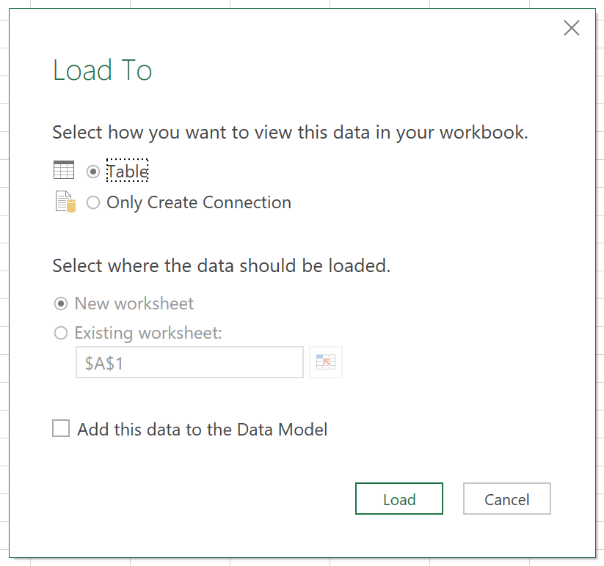

**file: 320-csv**

**video: 320-csv**

## Adding data

When you have asked for excel to get data from a folder, you can **drop more data into that folder and it will add it to your spreadsheet.**

**file: 321-adding-data**

**video: 321-adding-data**

## Get txt files

We’ve got two primary things we’re working with here:

* **get & transform** (power query)
* **data model** (power pivot)

What we are going to learn in this video is how to **get data from a folder** which has many files of different types. Think of this like cooking. I am going to show you how to make something. There will be a recipe which we follow. You do not need to memorize the recipe or be overwhelmed by the recipe. It is just a recipe. Follow the steps and you too can make what I’m showing you how to make. That said, **here’s the recipe**:

* show queries
* data → get & transform new query → from folder
  + choose your folder
* spirit of exploration & experimentation
  + combine
  + load
  + edit
    - query settings name
      * name your query
    - filter by extension
    - remove unwanted columns
    - split / replace / extract items in columns
    - expand binary content
      * combine files dialogue box
    - filter out headers in data
      * choose column with fewer unique entries
      * “load more data” if available
* check column TYPEs
* adjust “applied steps” as necessary
* close & load / close & load to
  + close & load
    - puts it as a table in a worksheet
  + close & load to

**file: 322-txt-files**

**video: 322-txt-files**

## Get xlsx files, single sheets

We’ve got two primary things we’re working with here:

* **get & transform** (power query)
* **data model** (power pivot)

Now we are going to get data from excel workbook “xlsx” files with each workbook having only one sheet. **Here’s the recipe**:

* show queries
* data → get & transform new query → from folder
  + choose your folder
* spirit of exploration & experimentation
  + combine
  + load
  + edit
    - query settings name
      * name your query
    - filter by extension (if necessary)
    - remove unwanted columns
      * inspect them first; delete if you don’t need
    - split / replace / extract items in columns (if necessary)
    - **add a custom column**
      * **Excel.Workbook([Content])**
    - delete binary content
    - filter out headers in data
      * choose column with fewer unique entries
      * “load more data” if available
    - add first row to header
* check column TYPEs
* adjust “applied steps” as necessary
* close & load / close & load to
  + close & load
    - puts it as a table in a worksheet
  + close & load to

**file:**

* **323-single-sheets**
* **folder: 323-data-01**
* **folder: 323-data-02**

**video: 323-single-sheets**

## Get xlsx files, many sheets

Now we are going to get data from excel workbook “xlsx” files with each workbook having a different number of sheets. **Here’s the recipe**:

* show queries
* data → get & transform new query → from folder
  + choose your folder
* spirit of exploration & experimentation
  + combine
  + load
  + edit
    - query settings name
      * name your query
    - filter by extension (if necessary)
    - remove unwanted columns
      * inspect them first; delete if you don’t need
    - split / replace / extract items in columns (if necessary)
    - **add a custom column**
      * **Excel.Workbook([Content])**
    - delete binary content
    - filter out headers in data
      * choose column with fewer unique entries
      * “load more data” if available
    - add first row to header
* check column TYPEs
* adjust “applied steps” as necessary
* close & load / close & load to
  + close & load
    - puts it as a table in a worksheet
  + close & load to

**file:**

* **324-many-sheets**
* **folder: 324-data-01**
* **folder: 324-data-02**

**video: 324-many-sheets**

## Data preparation

Here is how to take an Excel workbook and **save the data in a variety of different formats.**

**file:**

* **folder: 325-data-01**
* **folder: 325-data-02**

**video: 325-data-prep**

## Get txt, csv, accd, xlsx

Now we are going to **get data from a variety of different file types** and bring it into an excel workbook. **The recipe for this**

* create different queries for each file type
  + load as connection
* **combine queries**
  + **append**

**file: 326-many-file-types**

* **folder: 326-data-01**
* **folder: 326-data-02**

**video: 326-many-file-types**

## Get web

The ability to **get data from web** only works some of the time. Grabbing a table of data by inspecting the HTML is my favorite method for grabbing data from the web.

**file: 327-get-web**

**video: 327-get-web**

## Get JSON

There is a very new feature in Excel which allows you to **get JSON.** This feature has not been released in all versions of Excel yet.

**video: 328-get-json**

# Exercises - Ninja Level 23

## Hands-on exercise #1

Using the two files associated with this exercise, **use get & transform to** **GET the data** and load it into a workbook. Do this using:

* new query → from file → from folder
  + try three different ways:
    - edit
    - edit custom column
    - combine & edit

**file:**

* **329-data-01**
* **329-data-02**
* **329-LIVE**

**video: 329-hands-on-01**

## Hands-on exercise #2

Using the two files associated with this exercise, **use get & transform to** **GET the data** and load it into a workbook. Do this using any of the three below methods - you will need to **troubleshoot an error:**

* new query → from file → from folder
  + try three different ways:
    - edit
    - edit custom column
    - combine & edit

**file:**

* **330-data-01**
* **330-data-02**
* **330-LIVE**

**video: 330-hands-on-02**

## Hands-on exercise #3

Using the two files associated with this exercise, **use get & transform to** **GET the data** and try to load more than 1,048,576 records into a table. You will not be able to load this many records. The point of this exercise is to fail at loading the data.

**file:**

* **331-data-1048576-plus-01**
* **331-data-1048576-plus-02**
* **331-LIVE**

**video: 331-hands-on-03**

## Hands-on exercise #4

Using the two files associated with this exercise, **use get & transform to** **GET the data** and **load as connection** more than 1,048,576 records into the data model. Then create a pivot table.

**file:**

* **332-data-1048576-plus-01**
* **332-data-1048576-plus-02**
* **332-LIVE**

**video: 332-hands-on-04**

## Hands-on exercise #5

We have data from two years: 2020 & 2021. We need to get all of that data together and then do some analysis on it:

* Create a **connection** to all of the sheets in each workbook.
* Use append to **append** the appropriate data together.
  + add the appended data to the **data model**
  + create **relationships** between the data
  + add **measures** to the data in the transactions table
    - Transaction Amount
      * total (aka, sum)
      * average
      * count
* create a **pivot table**

**file:**

* **333-1048576-plus-2020**
* **333-1048576-plus-2021**

**video: 333-hands-on-05**

# Transforming data

## Overview

You are doing great. Look at what we’ve learned so far in the advanced course:

* financial functions
* pivot tables
* **data model** (power pivot)
  + 1,048,576+
  + create relationships
* **get & transform** (power query)
  + from file types
  + from folder
    - add data to folder
  + from web
  + as connection
* **get & transform** (power query)
  + from table

**file: 334-get-transform.xlsx**

**video: 334-overview**

## Split by delimiter

Get and transform has a “**split by delimiter**” tool. We can use the “split by delimiter” tool to have more control over splitting data. To do this, we will

* create a table of data
* data → get and transform → from table
* transform
  + fill down
  + fill up
  + split by delimiter
    - left most
    - right most

**file:**

* **335-transform-split**
* **335-name-generator**

**video: 335-split-by-delimiter**

## Pivot

When we pivot data, we take a table of data and then cross analyze it. This is my term, but this is how I think of pivot tables - they allow us to cross-analyze our data. What does this mean? If I have a big table of data, I could organize that data by:

* **row**
* **column**
* **value**

For example, I could have:

* **row:** manufacturer
* **column:** region
* **value:** sum of total

Another example:

* **row:** total
  + group by 1000
* **value:** count of total

Another example:

* **row:** total
  + group by 1000
* **value:**
  + count of total
  + average of total

Another example:

* **row:** salesperson
* **column:** region
* **value:** count of total

**file: 336-pivot**

**video: 336-pivot**

## Unpivot

Just as we can pivot data, so too we can unpivot data. When you unpivot data, the question you want to ask yourself is **what do you want to be your row?** Generally speaking, you only want one item for your row. Everything else will unpivot against that one item. For that one item which is your row, you will then get the rest of the data in that row. The best way to learn this is to see it in action and to try it. You could also ask yourself, **What are the values in the center which I want unpivoted?**

**file: 337-unpivot**

**video: 337-unpivot**

## Replace

Inside the “get & transform” area, once you are in the query editor, you can choose replace. Replace allows you to **replace certain text.**

**file: 338-replace**

**video: 338-replace**

## Extract

Inside the “get & transform” area, once you are in the query editor, you can choose extract. Extract is much like split. Extract allows you to **extract text.**

**file: 339-extract**

**video: 339-extract**

## Format

Inside the “get & transform” area, once you are in the query editor, you can choose format. Format allows you to format text, like making text all uppercase or lowercase.

**file: 340-format**

**video: 340-format**

# Exercises - Ninja Level 24

## Hands-on exercise #1

Using the data in this exercises file, get the following data into its own column:

* title
* first name
* last name
* post-nominal letters
* email
* email provider

**file: 341-hands-on-01**

**video: 341-hands-on-01**

## Hands-on exercise #2

Find a directory of users online. Extract the contact information of those users. You may need to copy/paste the info into the URL bar, then copy it back out of there and save all of the information to a text file. I will use the [Harvard Graduate School of Education](https://www.gse.harvard.edu/directory/faculty).

**file: 342-hands-on-02**

**video: 342-hands-on-02**

## Hands-on exercise #3

Using the workbook associated with this exercise, **pivot the data** using these guidelines:

* **row:** manufacturer
* **column:** region
* **value:** sum of total

**file: 343-hands-on-03**

**video: 343-hands-on-03**

## Hands-on exercise #4

Using the workbook associated with this exercise, **unpivot the data.** To do this you will need to

* copy the pivot table
  + paste it as values
* turn that data into a table
* create a query from the table
* unpivot

**file: 344-hands-on-04**

**video: 344-hands-on-04**

## Hands-on exercise #5

Using the workbook associated with this exercise, **transform the data** in the following ways:

* replace “protonmail.com” with “protonmail.org”
* fill down “east” “west” “south” “north”
* fill up “management” “production” “finance” “marketing”
* replace 444 with 777
* replace 76477 with 77777
* replace all 7’s in column “e” with 9’s

**file: 345-hands-on-05**

**video: 345-hands-on-05**

## Hands-on exercise #6

**Extract** the emails for the workbook.

**file: 346-hands-on-06**

**video: 346-hands-on-06**

## Hands-on exercise #7

Get the first name and last name into their own rows. Use a **conditional column** to do this. Make the names all **uppercase**.

**file: 347-hands-on-07**

**video: 347-hands-on-07**

# Append & merge

## Append

We have already seen append in action. For thoroughness, however, this entire video is devoted to showing how to **append two queries**.

**file: 348-append**

**video: 348-append**

## Append updating

Once you have queries appended to each other, you can **add data** to one of the original tables from which a query was created, and everything updates.

**file: 349-append-update**

**video: 349-append-update**

## Merge & joins

Merging requires us to **match data from two datasets**. Merging is like a powerful vlookup. Using two datasets, we will match data based upon a common column. When we merge data, we are taking different sets of data and bringing them together. Merging data is also known as joining data.

**file: 350-merge**

**video: 350-merge**

## Left outer join

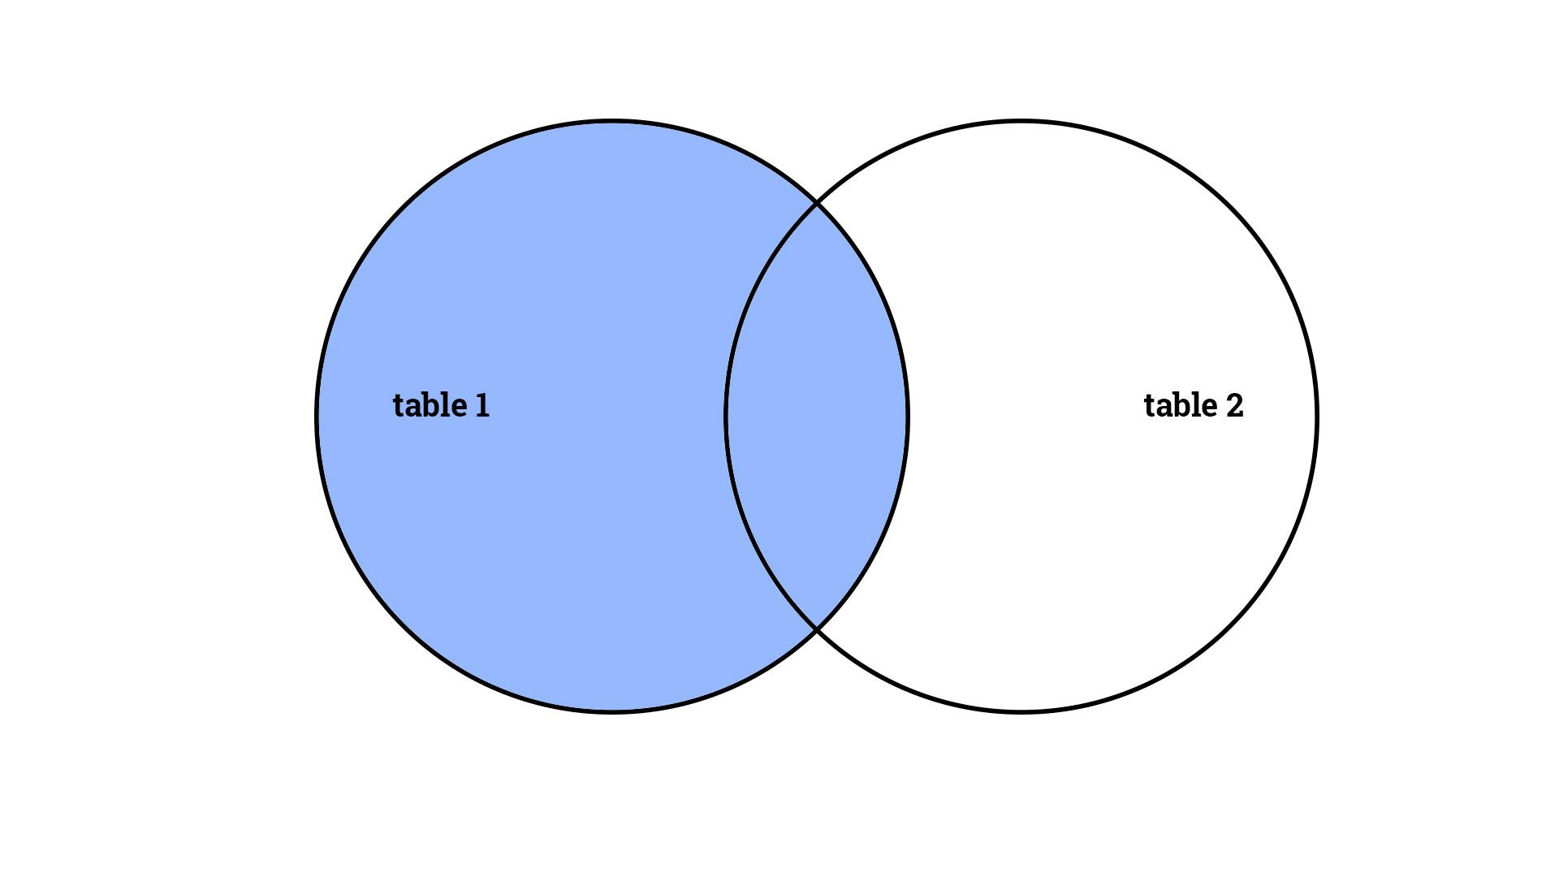

**file: 351-left-outer**

**video: 351-left-outer**

## Right outer join

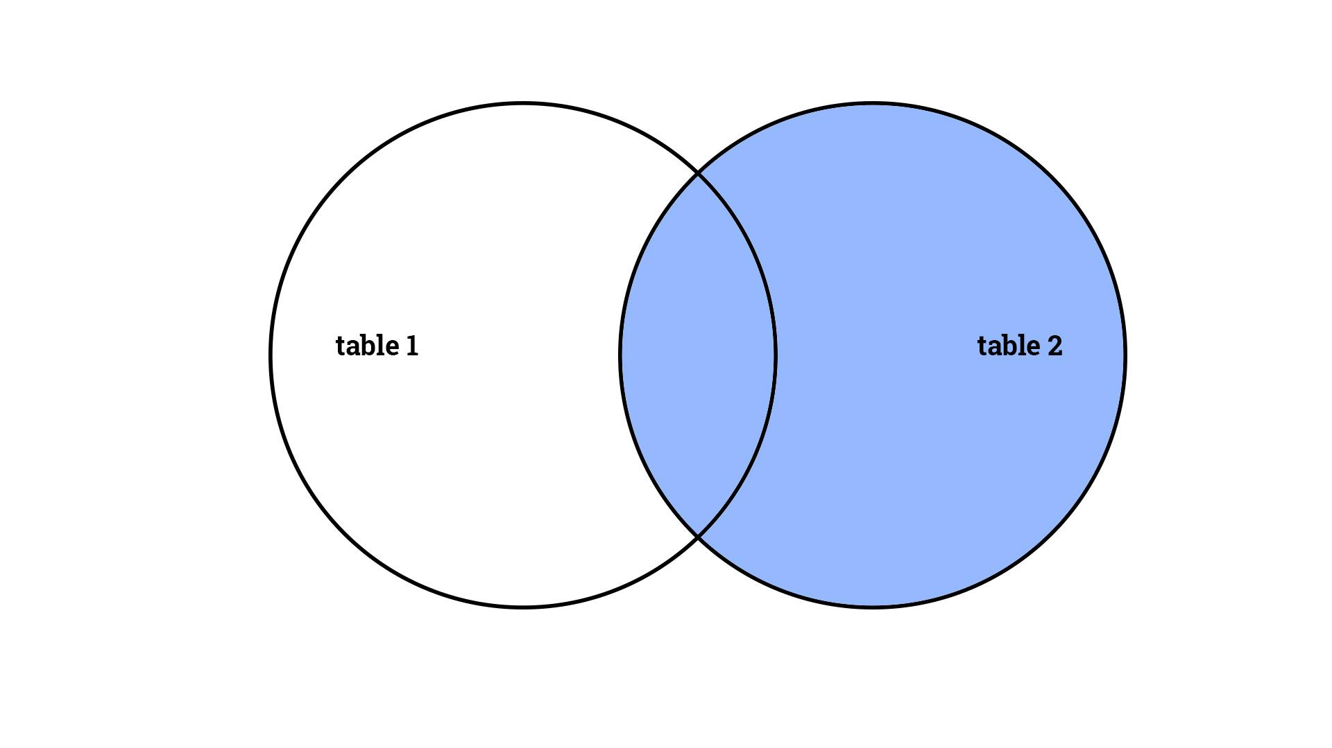

**file: 352-right-outer**

**video: 352-right-outer**

## Full outer join

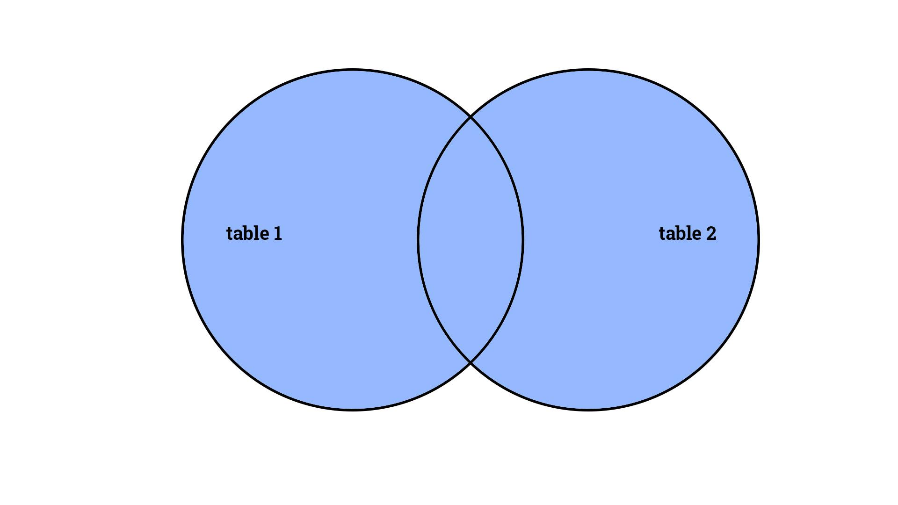

**file: 353-full-outer**

**video: 353-full-outer**

## Inner join

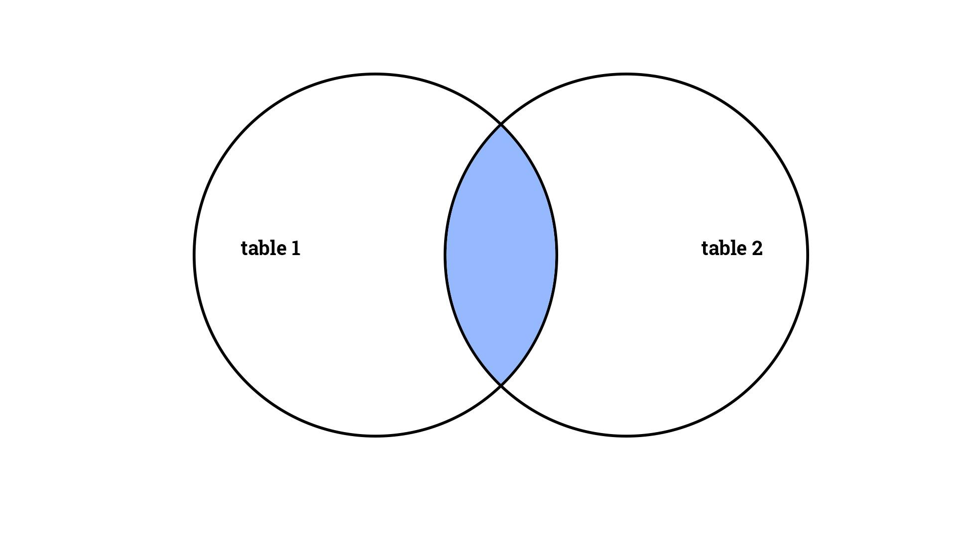

**file: 354-inner**

**video: 354-inner**

## Left anti join

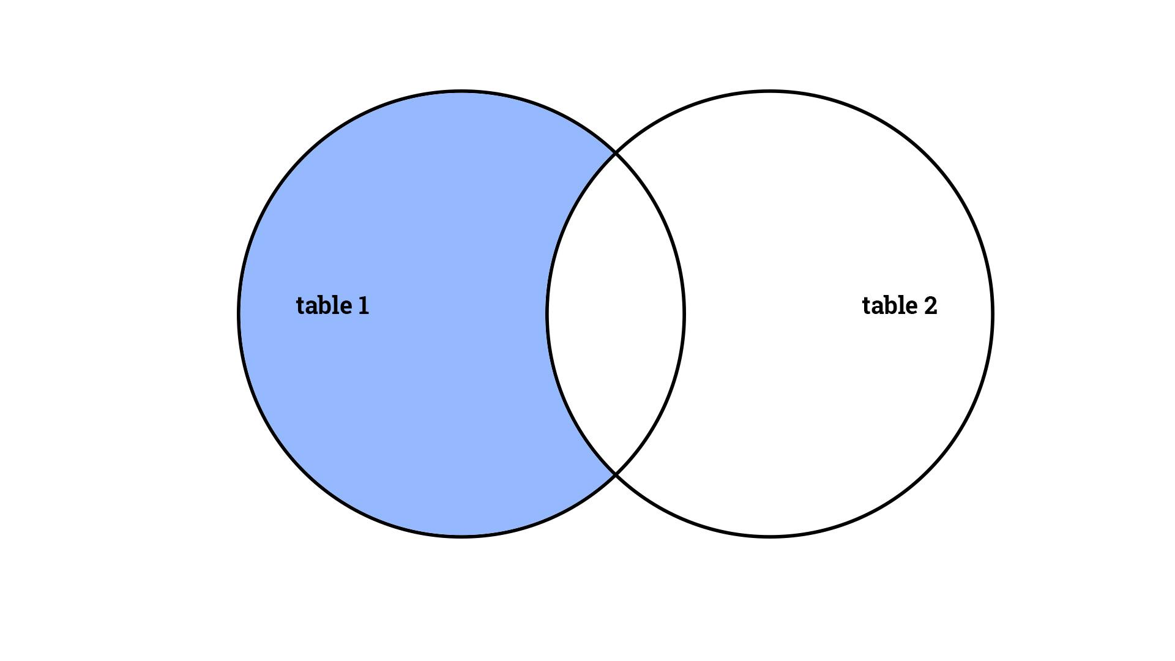

**file: 355-left-anti**

**video: 355-left-anti**

## Right anti join

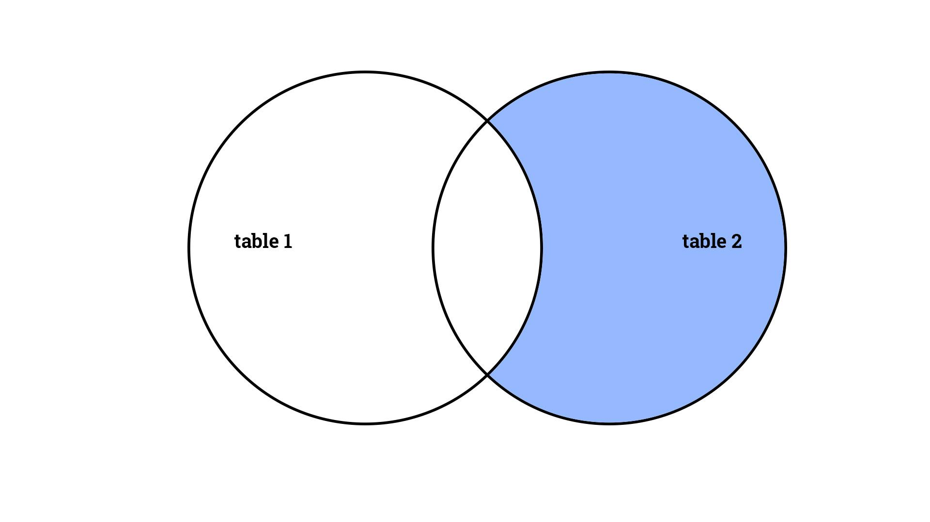

**file: 356-right-anti**

**video: 356-right-anti**

# Exercises - Ninja Level 25

## Hands-on exercise #1

Using the workbook associated with this exercise, **append the two sets of data** together using the query editor.

* Only create a connection to the queries of each table.
* For the append table, place it in a worksheet.

**file: 357-hands-on-01**

**video: 357-hands-on-01**

## Hands-on exercise #2

Additional sales transactions for February have been found. **Add the new data to your table** using copy/paste so that they are included in the appended data.

**file: 358-hands-on-02**

**video: 358-hands-on-02**

## Hands-on exercise #3

In the workbook associated with this exercise, there is a “Guest List” worksheet and an “RSVP” worksheet. Do a **left outer join** on the data in the “Guest List” worksheet and the “RSVP” worksheet.

**file: 359-hands-on-03**

**video: 359-hands-on-03**

## Hands-on exercise #4

In the workbook associated with this exercise, there is a “Guest List” worksheet and an “RSVP” worksheet. Do a **right outer join** on the data in the “Guest List” worksheet and the “RSVP” worksheet.

**file: 360-hands-on-04**

**video: 360-hands-on-04**

## Hands-on exercise #5

In the workbook associated with this exercise, there is a “Guest List” worksheet and an “RSVP” worksheet. Do a **full outer join** on the data in the “Guest List” worksheet and the “RSVP” worksheet.

**file: 361-hands-on-05**

**video: 361-hands-on-05**

## Hands-on exercise #6

In the workbook associated with this exercise, there is a “Guest List” worksheet and an “RSVP” worksheet. Do a **inner join** on the data in the “Guest List” worksheet and the “RSVP” worksheet.

**file: 362-hands-on-06**

**video: 362-hands-on-06**

## Hands-on exercise #7

In the workbook associated with this exercise, there is a “Guest List” worksheet and an “RSVP” worksheet. Do a **left anti join** on the data in the “Guest List” worksheet and the “RSVP” worksheet.

**file: 363-hands-on-07**

**video: 363-hands-on-07**

## Hands-on exercise #8

In the workbook associated with this exercise, there is a “Guest List” worksheet and an “RSVP” worksheet. Do a **right anti join** on the data in the “Guest List” worksheet and the “RSVP” worksheet.

**file: 364-hands-on-08**

**video: 364-hands-on-08**

# Data visualization

## Overview

You’re doing great! **Look at how far you’ve come!** Here is what we have covered, and what we will be learning next!

**file: 365 image files**

**video: 365-overview**

## 3-D map

The 3-D map feature allows us to **map data by location.** 3D Maps lets you discover insights you might not see in traditional two-dimensional (2-D) tables and charts .

**file: 366-3d**

**video: 366-3d**

## 3-D map II

We will further explore how to work with 3-D maps in this video by looking at **mapping power station data**.

**file: 367-3d**

**video: 367-3d**

## 3-D map III

We will further explore how to work with 3-D maps in this video by looking at **mapping chicago drug data.**

**file: 368-3d**

**video: 368-3d**

## 3-D map IV

We will further explore how to work with 3-D maps in this video by looking at **mapping chicago drug data again.**

**file: 369-3d**

**video: 369-3d**

## 3-D map animation

The 3-D map feature allows us to **map data by location.** 3D Maps lets you discover insights you might not see in traditional two-dimensional (2-D) tables and charts. When you create an animation, you want to think of your scenes as “key frames.” The video will then animate between your key frame scenes.

**file: 370-animation**

**video: 370-animation**

## Themes

Themes allow us to **quickly change the look** of our workbook.

**file: 371-themes**

**video: 371-themes**

## Defined names

Names allow us to **refer to cells, or ranges, by a name**.

**file: 372-defined-names**

**video: 372-defined-names**

## Defined names & tables

Names allow us to **refer to cells, or ranges, by a name.**

**file: 373-defined-names-tables**

**video: 373-defined-names-tables**

## Defined names management

Names allow us to **refer to cells, or ranges, by a name.**

**file: 374-defined-names-management**

**video: 374-defined-names-management**

## Formula auditing

Formula auditing helps us **find errors with our formulas.** One of the formula auditing tools we can use allows us to see what cells a formula references.

**file: 375-formula-auditing**

**video: 375-formula-auditing**

## Error checking

Formula auditing also offers us an additional useful tool: **error checking.**

**file: 376-formula-auditing**

**video: 376-formula-auditing**

## Evaluate formula

Formula auditing also offers us an additional useful tool: **evaluate formula.**

**file: 377-formula-auditing**

**video: 377-formula-auditing**

## Watch window

Add cells to the watch window to **keep an eye on their values** as you change values in other areas in your workbook.

**file: 378-watch**

**video: 378-watch**

## Calculation

The calculation area allows you to **calculate** your **formulas** either **automatically** or **manually**.

**file: 379-calculation**

**video: 379-calculation**

# Exercises - Ninja Level 26

## Hands-on exercise #1

Build a **3-D map** with the following criteria:

* heatmap
* value: WAT

Create a **tour** with four scenes.

**file: 380-hands-on-01**

**video: 380-hands-on-01**

## Hands-on exercise #2

Build a **3-D map**. Create a **tour** showing the west coast of America.

**file: 381-hands-on-02**

**video: 381-hands-on-02**

## Hands-on exercise #3

Build a **3-D map** showing the drug crimes in Chicago by “Beat”. Create a **tour**.

**file: 382-hands-on-03**

**video: 382-hands-on-03**

## Hands-on exercise #4

Change the **theme** of the workbook.

**file: 383-hands-on-04**

**video: 383-hands-on-04**

## Hands-on exercise #5

In this hands-on exercise, we will work with **defined names**. Open the workbook. There are four worksheets. For each one, do what is specified.

* table
  + write formulas to calculate the TOTAL and PERCENTAGE GRADE
    - don’t use functions like “sum”
* give names
  + give a name to each of the values
  + write a formula to calculate the total
* turn into table
  + turn this into a table
  + write a formula to calculate the total
* get rid of names
  + remove names assigned to cells in this worksheet

**file: 384-hands-on-05**

**video: 384-hands-on-05**

## Hands-on exercise #6

Use **formula auditing** to find what’s wrong with the formulas in the worksheet.

**file: 385-hands-on-06**

**video: 385-hands-on-06**

# Collaborating

## Signature line

A signature line allows you to **capture a digital signature** from someone. A digital signature [confirms](https://support.office.com/en-us/article/Add-or-remove-a-digital-signature-in-Office-files-70d26dc9-be10-46f1-8efa-719c8b3f1a2d#__toc311526850) that the information originated from the signer and has not been altered.

* Certificate authority (CA) A certificate authority is an entity similar to a notary public. It issues digital certificates, signs certificates to verify their validity and tracks which certificates have been revoked or have expired.

**file: 386-signature**

**video: 386-signature**

## Comments

You can add notes to individual cells by using comments to **give your reader additional context** for the data it contains. When a cell has a comment, a red indicator appears in the corner of the cell. When you rest the pointer on the cell, the comment appears.

**file: 387-comments**

**video: 387-comments**

## Accessibility

The Accessibility Checker tool finds accessibility issues. The tool generates a report of issues that could make your content difficult for **people with disabilities** to understand. Accessibility Checker also explains why you should fix these issues and how to fix them.

**file: 388-accessibility**

**video: 388-accessibility**

## Protect (lock)

To **prevent other users from viewing** hidden worksheets, adding, moving, deleting, or hiding worksheets, and renaming worksheets, you can protect the structure of your Excel workbook with a password.

**file: 389-protect**

**video: 389-protect**

# Exercises - Ninja Level 27

## Hands-on exercise #1

Open the workbook associated with this exercise:

* add a **signature line**
  + insert ribbon
* add a **comment**
  + review ribbon
* only allow users to **select** the highlighted cells
  + review ribbon
* add a password to **open** the workbook
  + f12
* add a password to **modify** the workbook
  + f12

**file: 390-hands-on-01**

**video: 390-hands-on-01**

# Automation

## Understanding macros

Macros allow you to **automate your work.** If you have a process that you repeat over and over, you can “record” that process and then assign that process to a shortcut key or an icon.

**file: 391-understanding-macros**

**video: 391-understanding-macros**

## Relative reference macros

If you need to move your cell as you record a macro, then turn on **relative references** for your macro.

**file: 392-rel-ref-macros**

**video: 392-rel-ref-macros**

# Exercises - Ninja Level 28

## Hands-on exercise #1

Copy data from the web. Paste it into excel. Use a macro to get the **data arranged well**.

**file: 393-hands-on-01**

**video: 393-hands-on-01**

# Excel & Word integration (OLE)

## Object linking & embedding (OLE)

Object linking and embedding allows you to either **LINK or EMBED content from excel into ms word.** When content is linked the content in word updates when the source data in excel updates.

**file: 394-ole**

**video: 394-ole**

# Exercises - Ninja Level 29

## Hands-on exercise #1

Create as pivot table. Paste the pivot table into MS Word both as an **embed and a link**. Update the data. Inspect what is in word.

**file: 395-hands-on-01**

**video: 395-hands-on-01**

# Farewell

## Great work!

You have done great work - the greatest work. You have taken steps to create a better life for yourself, and for others. As an individual improves their own life, they improve the world. The skills you are acquiring are some of the most valuable skills demanded today: knowing how to use Excel. Great job.

Next Steps

* [Follow me on Twitter](https://twitter.com/Todd_McLeod)
* <https://goo.gl/uNb5QJ>

**video: 396-farewell**